RECENT ADVANCES IN FUEL CELL APPLICATIONS
WITH A FOCUS ON THE HYDROGEN ECONOMY
YOLONDA NEWMAN
Department of Nuclear, Plasma and Radiological Engineering, University of Illinois at Urbana-
Champaign, Urbana, IL 61801 USA
yzanagl2@illinois.edu
MAGDI RAGHEB
Department of Nuclear, Plasma and Radiological Engineering, University of Illinois at Urbana-
Champaign, 216 Talbot Laboratory, 104 South Wright Street, Urbana, Illinois 61801, USA.
mragheb@illinois.edu, http://www.mragheb.com
“Water decomposed into its primitive elements… will be the coal of the future.” — Jules Verne (1874)
ABSTRACT: Advances in Fuel Cell applications have largely driven the so-called Hydrogen Economy. Herein we present recent developments in both Fuel Cell technology and hydrogen production that are important to the fuel cell market. Principle features of common fuel cell types and their applications are also reviewed. Much of the industry advancements have been made possible by governmental investments primarily in the transportation field such as cars, buses, trains, trucks, and boats. We consider challenges to the Hydrogen Economy related to finding safe and efficient ways of producing, storing, and distributing hydrogen supplies. Intense research efforts in aerospace and breakthroughs in novel materials for cathodes and catalysts show great promise for increasing efficiency, improving fuel cell life, and decreasing costs for hydrogen production via the electrolysis process. Current safety incidents involving hydrogen explosions and fires are reviewed and a possible way forward on the solution for addressing the refueling stations hurdle.
KEY WORDS: Electrolysis, Energy Storage, Fuel Cell, Hydrogen Economy
INTRODUCTION
Development of a Hydrogen-Based Economy is part of the vision for phasing out dependence on fossil fuels. To consider hydrogen as a possible energy storage “component” that is connected to the power grid, it would necessitate the inclusion of a type of fuel cell as shown in Figure 1. The energy input to the electrolyzer could alternately be supplied from renewable sources rather than from the electric grid. According to the National Renewable Energy Laboratory (NREL) the Round-Trip-Efficiency for hydrogen energy storage is about 35% compared to 95% for DC Battery Storage [1]. Nevertheless, hydrogen storage has economic advantage of longer storage capabilities which could offset lower efficiency as storage times increase. The main challenges of the Hydrogen Economy are developing safe and low-cost ways to generate, store, and distribute a hydrogen supply.
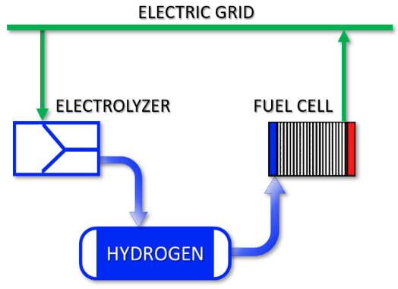 | Figure 1. Hydrogen as an energy storage connected to the grid system. (Adapted from A. Headley — Sandia National Laboratories and S. Schoenung —Longitude 122 West, Inc.)

The Fuel Cell industry is advancing at a steady pace and market research has projected a stable growth in revenue as shown in the Figure 2 graph. Substantial government investment has provided research grants and infrastructure investments to improve designs and expand applications of hydrogen fuel cells.
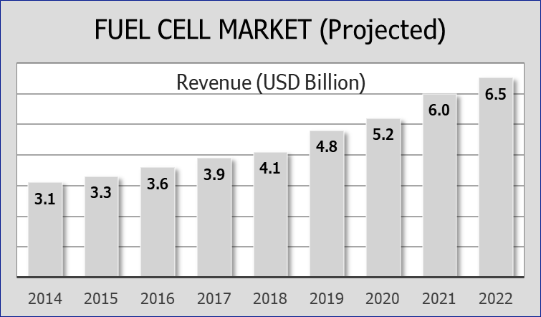 | Figure 2. Market Research has projected a steady growth in revenue for the Fuel Cell Market [2].
FUEL CELL TYPES AND PROPERTIES
Today, the main electrolyte types are Alkali, Polymer Electrolyte Membrane, Phosphoric Acid, Molten Carbonate and Solid Oxide (see Figure 3). The main advantage of the solid-state electrolyte is the increased safety. It does not leak toxic liquids; it has a low flammability and a low self-discharge. The solid-state electrolyte also has a higher achievable power density and thermal stability. Another benefit of the Solid Oxide fuel cell is the very high operating temperatures that can be used to reform natural gas or biogas [3]. Fuel Cells operating at lower temperatures are most often used in vehicles and portable applications while those with operating at higher temperatures are better for stationary applications [4].
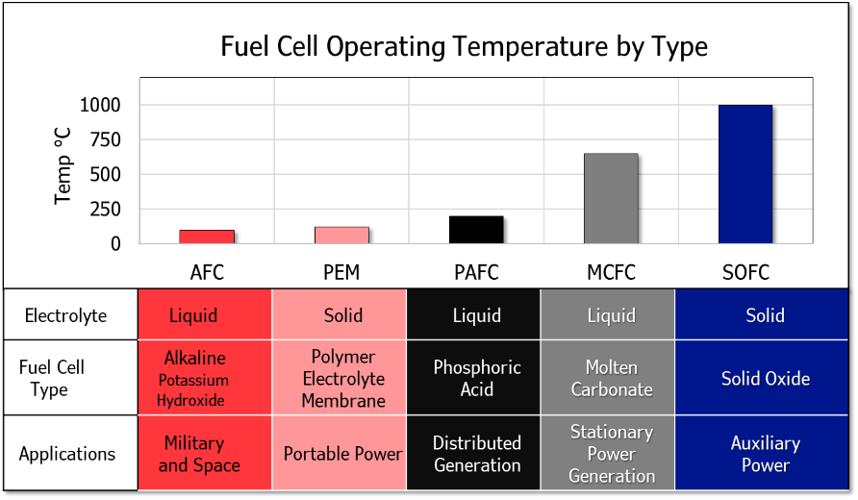 | Figure 3. Fuel Cell types, operating temperatures, and common applications.
INDUSTRY APPLICATIONS OF HYDROGEN FUEL CELLS
Implementing Hydrogen Fuel Cells for material handling in the warehouse has improved air quality for the workers by switching from propane-based equipment, and when compared to electric battery-operated equipment, the industry has seen reduced overall plug loads. The US Dept of Energy reports there are more than 35,000 hydrogen fuel cell forklifts in use across the United States [5].
Hospitals, data centers, and other critical load applications require an uninterruptible power supply. Hydrogen fuel cell power is also providing non-stop generation for military operations and emergency disaster relief. Over 500 MW of fuel cell power serves more than 40 states in the U.S. [5]
In the distribution sector, General Motors will supply its hydrogen power fuel cells, “Hydrotec Power Cubes,” for use in the Navistar International Semi Tractors. Each semi will use 2 cubes that can provide up to 80 kilowatts of net power each, for a range of 500 miles [6]. These fuel cell cubes can be fitted to Class 5, 6, 7 or 8 trucks, have a proprietary membrane electrode assembly, and allow for rapid refueling see Figure 3. Commercial availability is scheduled for 2024.
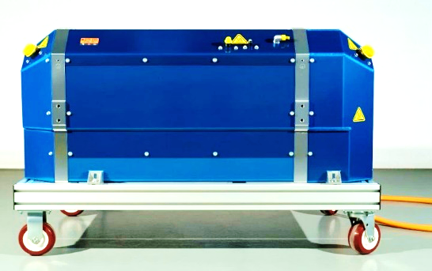 | Figure 4. Hydrotec Fuel Cell Power Cubes has over 300 individual fuel cell components with proprietary controls. [6]
The United Kingdom railway is converting existing Class 321 passenger trains to run on Hydrogen. They have codenamed their trains ‘Breeze’ and are scheduled to deploy in 2022. Their primary focus will be on areas where overhead electric wires are impractical or visually intrusive [7].
The auto industry has impacted development of the Polymer Electrolyte Membrane (PEM) fuel cell, which in turn has been important in the establishment of the Hydrogen Economy [8]. The US Department of Energy Fuel Cell Program has set critical technical targets for fuel cell systems as shown in Table 1. Fuel cell system efficiency must also take into consideration losses due to operational processes as well as stack construction and can be calculated by:
$η_{fcs}=η_{stack}∙η_{BOP}∙η_{fuel}= \frac{V_{cell}}{1.482}∙\frac{E_{net}}{E_{stack}}∙\frac{Q_{reaction}}{Q_{reaction}+Q_{purging}}$ (1)
where, V_{cell} and E_{stack} is the average cell voltage and output energy of fuel cell stack, respectively. E_{net} is the output energy of fuel cell system. Q_{reaction} is the amount of hydrogen consumed in electrochemistry reactions and Q_{purging} is the amount of hydrogen purged [8].
Table 1. Technical Targets of Fuel Cell Power Systems. Adapted from [8]
 | Characteristic | Target | Unit
 | Peak power efficiency | 65 | %
 | Power density | 650 | W L−1
 | Cold start-up temperature | −30 | °C
 | Durability in automotive drive cycle | 5,000 | hours
 | Storage hydrogen pressure | 70 | MPa
 | Fuel Cell net efficiency * | 70 | %
 | Cost | 40 | $/kW
 | * The ratio of DC output energy to the lower heating value of input hydrogen: η_{fcs} = E_{DC}/Q_{H2}

The 2022 BMW i Hydrogen Next Fuel Cell Electric Vehicle (HFCEV) will have its hydrogen fuel tanks pressurized to 70 MPa and achieve 368 horsepower (274 kW). The high-voltage battery is fed by braking energy as well as from the fuel cell [9]. (See Figure 5).
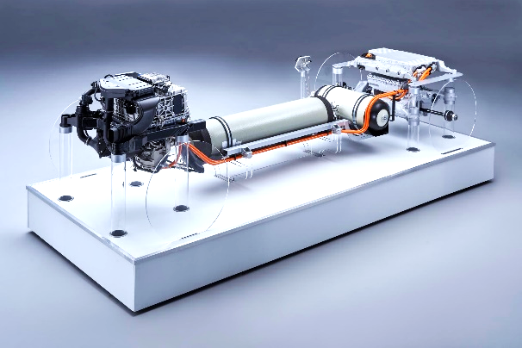 | Figure 5. 2022 BMW i Hydrogen Next model HFCEV with liquid hydrogen storage tanks pressurized to 70 Mpa [9].

Hydrogen fuel cells improve the performance of electric buses by generating onboard power from hydrogen to recharge the batteries. Over 60 hydrogen fuel cell buses are providing transit service in the United States. Many of these buses have exceeded 20,000 hours without major repairs or replacement of the fuel cell stack [10]. This is comparable to the life expectancy of a diesel engine in a transit bus. The fuel cell has no moving parts except for the air delivery and cooling systems. In March 2019, the Xcelsior CHARGE H2 built by New Flyer of America Inc. completed the Federal Transit Administration Model Bus Testing Program [11]. The Champaign-Urbana Mass Transit District (MTD) is the first in the nation to commercially order two 60-foot Xcelsior buses. These buses use a Proton Electrolyzer with compressed hydrogen in an 85 kW Fuel Cell. MTD will install a stationary 1MW hydrogen refueling system with a capacity to recharge up to 12 buses [12].
Since 2004, Polymer-Electrolyte-Membrane (PEM) fuel cells have been used in submarines. However, a 4th generation metal hydride cylinder has been developed by German ThyssenKrupp Marine Systems for submarine applications. They explain “[since] these cylinders do not contain any active components…and hydrogen molecules are held within the crystal lattice of the hydride, failure is reduced to a minimum. And since hydrogen is fed to the system in its purest form, no chemical conversion is required [13].”
Hydrogen Fuel Cells are being used in the San Francisco Bay Ferry (see Figure 6). The ferry named Water-Go-Round, has a 360 kW Proton Exchange Membrane Fuel Cell, carries 242 kg of H₂ compressed to 25 MPa, and can hold 84 people [14]. Because ferries operate close to shore, it is easier to refill the hydrogen tanks and recharge batteries.
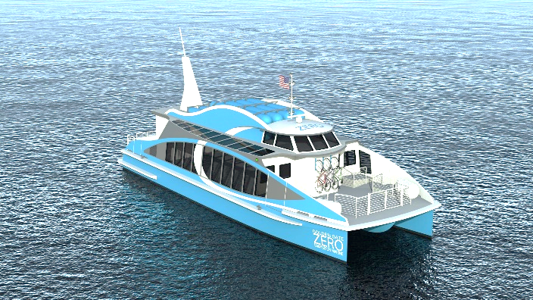 | Figure 6. San Francisco Bay ferry powered by hydrogen fuel cell [15].
CURRENT RESEARCH WITH HYDROGEN FUELS
From South Korea, an advanced power systems company called MetaVista, conducted a record-breaking test flight of nearly 11 hours with a Quadcopter Drone powered with a hydrogen fuel cell. Their fuel cell system with a light-weight liquid hydrogen storage tank provides an energy density of 1,865 watt-hours per kilogram [16]. Some advantages of operating drones with fuel cell propulsion are low vibrations, quiet operation, longer flight times, and lower maintenance. Compared to battery recharging the fuel canister replacement is easy and fast.
The Aerodelft team of 44 students at the Technical University of Delft in the Netherlands has built a prototype aircraft with a glider design. The liquid hydrogen fuel tank will have 20 cm thick insulation to keep it cooled to -253˚C [17]. The crew-less design weighs about 113 pounds and carries two pounds of liquid hydrogen. Flight time and range are 7 hours and 311 miles. Their plan is to scale this up to carry two passengers after initial trials are completed and for a round-the-world flight by 2025. [18].
NASA has selected a team at the University of Illinois at Urbana-Champaign to examine new ways to build and power aircraft [19]. Led by Phillip Ansell of the Aerospace Engineering Department and co- investigator Kiruba Haran from the Electrical and Computer Engineering Department, they will consider both the Solid-Oxide and the Proton Exchange Membrane fuel cell designs (See Figure 7). According to their webpage:
Since the hydrogen would be stored at cryogenic temperatures, we also had the idea of doubling the use of this cryogen as a heat sink to enable superconducting electrical transmission and motor systems. These improvements in the drivetrain result in dramatic increases in the overall efficiency, specific power, and rated power capabilities for electric aircraft propulsion [20].

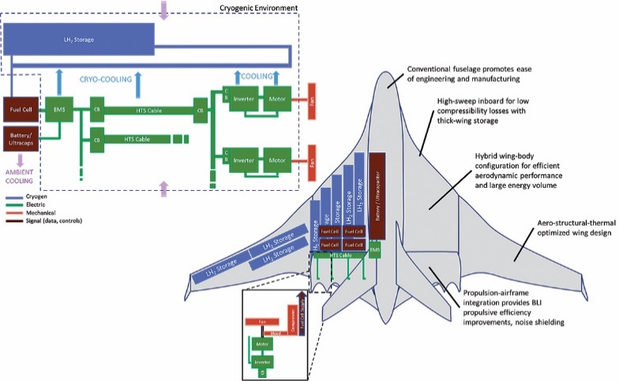 | Figure 7. University of Illinois Center for Cryogenic High-Efficiency Electrical Technologies for Aircraft (CHEETA) Concept of electric aircraft with cryogenic liquid hydrogen as energy storage [20].

Improvements in the electrolysis of water will help reduce costs of hydrogen production. In Australia, Dr. Alexandre Simonov from the Monash School of Chemistry, has led his team to develop an electrode where the dissolved material could be redeposited on the surface during operation. By redepositing precious metals, the fuel cells will last longer [21]. At the University of Arkansas Drs. Jingyi Chen and Lauren Greenlee have created a catalyst composed nanoparticles of iron and nickel around a nickel core (see Figure 8) which have been found to be more effective and efficient than other, more costly materials for the production of hydrogen through water electrolysis [22].
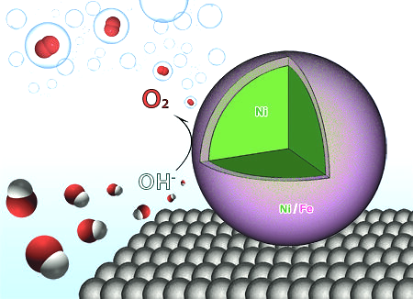 | Figure 8. Conceptual drawing of Nickel and Iron nanoparticles around a nickel core that serve to weaken hydrogen and oxygen bonds [22].
At the University of Toronto, Drs. Cao-Thang Dinh, Pelayo Garcia De Arquer and Ankit Jain have produced a catalyst to replace the high-cost platinum that must operate under acidic conditions. Their catalyst is made from copper, nickel and chromium that can perform below pH-neutral conditions. The presence of chromium oxides (CrO_{x}) was found to have a significant effect on the structure and oxidation state of Nickel (Ni) and Copper (Cu). This material has the possibility of operating with seawater without the need to desalinate it [23].
HYDROGEN ECONOMY CHALLENGES
In order for hydrogen to achieve an established place in the economy, safe and cost-efficient methods of production, storage and distribution must be attained. Since hydrogen is not an energy source, but an energy carrier similar to electricity, it requires energy input to produce it from other materials that contain it such as water and hydrocarbons. A variety of process technologies are available such as reforming of natural gas, coal gasification, electrolysis, and nuclear power methods. Hydrogen can be produced either at small-scale point-of-use sites, at medium-sized stations, and at large centralized facilities [3].
The United States uses over 10 million metric tons of hydrogen each year for industrial purposes, such as making fertilizer and refining petroleum, and 95 percent is produced from steam reforming methane [24]. In 2018, worldwide production of hydrogen was approximately 60 million metric tons [1]. Once generated from electrolysis or other method, hydrogen can be stored in gaseous, liquid, or bound states. Methods for storage currently being used are high-pressure gas tanks, cryogenic liquid tanks, gas pipelines, geologic storage in salt caverns, adsorption in metal hydrides, and bonding with liquid organic hydrogen carriers.
One chemical hydrogen storage scheme utilizes starch, an abundant and inexpensive renewable resource through photosynthesis. Starch can also be artificially produced and has the potential to reach very high hydrogen density as show in Figure 9 [25].
The stoichiometric reaction to produce 12 hydrogen molecules (H₂) from one anhydroglucose is:
$C_{6}H_{10}O_{5}+7H_{2}O=12H_{2}+6CO_{2}$ (2)
However, we must note the high carbon dioxide (CO2) produced with this reaction that would require remediation.
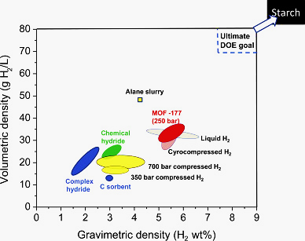
Figure 9. Comparison of various hydrogen storage technologies based on hydrogen density [25].

To meet the challenge of hydrogen distribution for refueling one idea that has been suggested is to initially focus on applications that are less dependent on the number of refueling stations. In this way attention to developing infrastructure for specific commercial vehicles and for specific locations, resources can be optimized. This would apply to trains, buses, and trucks for instance [26].
There have been fires and explosions in connection with hydrogen production and storage that continue to bring to the forefront the challenge of safety in the Hydrogen Economy (see Table 2). A helpful source for staying abreast of fuel cell and hydrogen safety codes and standards is found at the “Hydrogen/Fuel Cell Codes & Standards” website. Here the Fuel Cell & Hydrogen Energy Association (FCHEA) maintains a searchable online database to track detailed information about standards around the world [27].
Table 2. Recent Hydrogen Fires and Explosions
Date | Location | Event | Cause
Sept 2017 | Charleston, TN | Explosion at Production Facility | Faulty Piston
Feb 2018 | Diamond Bar, CA | Fire on Delivery Truck | Valve Leak
June 2019 | Sandvika, Norway | Explosion at Refueling Station | Plug Incorrectly Mounted
June 2019 | Santa Clara, CA | Fire and Explosion at Production Facility | Valve Leak
April 2020 | Longview, NC | Explosion at Production Facility | Under Investigation

CONCLUSIONS
The increasing motivations for development of renewable energy sources will definitely require energy storage technologies. Fuel Cell advancements continue to help the Hydrogen Economy grow in the marketplace due to their broad range of applications as well as their role in energy storage. Expanded government incentives, favorable policies for the adoption and application of fuel cells, and commercialization have also been supporting the growth of the fuel cells market. Safety and costs continue to be the greatest challenges facing the Hydrogen Economy.

REFERENCES
[1] | Statista, ""Global Hydrogen Production 2018 & 2030"," [Online]. Available: https://www.statista.com/statistics/1121207/global-hydrogen-production/. [Accessed 15 March 2021].
[2] | Zion Market Research, "Global Fuel Cells Market is Set for a Rapid Growth and is Expected to Reach USD 6.54 Billion by 2022," 25 September 2017. [Online]. Available: https://www.zionmarketresearch.com/news/fuel-cells-market. [Accessed 6 March 2021].
[3] | M. Ragheb, "Energy Storage Engineering," [Online]. Available: http://ragheb.co/NPRE%20498ES%20Energy%20Storage%20Systems/index.htm. [Accessed February 2021].
[4] | Wikipedia The Free Encyclopedia, "Solid-state electrolye," [Online]. Available: https://en.wikipedia.org/wiki/Solid-state_electrolyte. [Accessed 10 March 2021].
[5] | US Department of Energy, [Online]. Available: https://www.energy.gov/eere/articles/10-things-you-might-not-know-about-hydrogen-and-fuel-cells. [Accessed 12 March 2021].
[6] | General Motors, [Online]. Available: https://gmauthority.com/blog/2021/01/general-motors-to-supply-hydrotec-fuel-cell-cubes-to-navistar. [Accessed 18 March 2021].
[7] | Railway-News, [Online]. Available: https://railway-news.com/alstom-hydrogen-train-breeze-model-railtex/. [Accessed 20 March 2021].
[8] | G. Y. Y. L. H. G. C. W. S. W. X. a. T. Z. Wang, "Progress on design and development of polymer electrolyte membrane fuel cell systems for vehicle applications: A review.," Fuel Processing Technology, vol. 179, pp. 203-228, 2018.
[9] | A. Dorofte, "BMW i Hydrogen NEXT coming in 2022 with 368 horsepower," BMWBLOG, 30 March 2020. [Online]. Available: https://www.bmwblog.com/2020/03/30/bmw-i-hydrogen-next-coming-in-2022-with-368-horsepower/. [Accessed 24 February 2021].
[10] | U.S. Department of Energy, "Hydrogen and Fuel Cell Tecnologies Office," January 2019. [Online]. Available: https://www.energy.gov/eere/fuelcells/fact-month-january-2019-five-fuel-cell-buses-united-states-have-exceeded-doedot. [Accessed 16 March 2021].
[11] | Green Car Congress, [Online]. Available: https://www.greencarcongress.com/2019/03/20190313-nfi.html. [Accessed 9 March 2021].
[12] | Fuel-Cells-Works, [Online]. Available: https://fuelcellsworks.com/news/mtd-expands-zero-emission-mobility-in-illinois-with-new-flyer-xcelsior-charge-h2-buses/. [Accessed 9 March 2021].
[13] | NAVALTODAY, "TKMS develops 4th generation fuel cell system for submarines," 9 September 2019. [Online]. Available: https://www.navaltoday.com/2019/09/09/tkms-develops-4th-generation-fuel-cell-system-for-submarines/. [Accessed 22 March 2021].
[14] | GRIST, "A ferry that runs on hydrogen fuel cells is coming to San Francisco," 25 June 2018. [Online]. Available: https://grist.org/article/a-ferry-that-runs-on-hydrogen-fuel-cells-is-coming-to-san-francisco/. [Accessed 9 March 2021].
[15] | Golden Gate ZERO Emission Marine, "Projects - The Water-Go-Round," [Online]. Available: https://ggzeromarine.com/projects/. [Accessed 16 March 2021].
[16] | P. C. MIller, "Hydrogen fuel cell-powered drone sets new flight time record," UAS Magazine, 15 February 2019. [Online]. Available: http://uasmagazine.com/articles/1990/hydrogen-fuel-cell-powered-drone-sets-new-flight-time-record. [Accessed 14 March 2021].
[17] | L. McGill, "Dutch Student Team Designs Hydrogen-Powered Aircraft," 25 April 2019. [Online]. Available: https://aerodelft.nl/dutch-student-team-designs-hydrogen-powered-aircraft/. [Accessed 17 March 2021].
[18] | D. Bachmann, "Robb Report," 2021 8 March. [Online]. Available: https://robbreport.com/motors/aviation/worlds-first-aircraft-powered-by-hydrogen-fuel-cells-1234600400/. [Accessed 21 March 2021].
[19] | J. Richardson, "NASA To Provide $6 Million For Electric Aircraft Research At Univ. Of Illinois," CleanTechnica, 21 May 2019. [Online]. Available: https://cleantechnica.com/2019/05/21/nasa-to-provide-6-million-for-electric-aircraft-research-at-univ-of-illinois/. [Accessed 16 March 2021].
[20] | elisak2@illinois.edu, "NASA Backs Development of Cryogenic Hydrogen System to Power All-Electric Aircraft – CHEETA," 18 February 2020. [Online]. Available: https://ceme.ece.illinois.edu/2020/02/nasa-backs-development-of-cryogenic-hydrogen-system-to-power-all-electric-aircraft-cheeta/. [Accessed 22 March 2021].
[21] | A. Simonov, "Electrolysis breakthrough could solve the hydrogen conundrum," PhysOrg, 25 September 2019. [Online]. Available: https://phys.org/news/2019-09-electrolysis-breakthrough-hydrogen-conundrum.html. [Accessed 16 March 2021].
[22] | C. Shumaker, "Researchers find cost-effective method for hydrogen fuel production process," PhysOrg , 19 March 2019. [Online]. Available: https://phys.org/news/2019-03-cost-effective-method-hydrogen-fuel-production.html. [Accessed 16 March 2021].
[23] | T. Irving, "Low-cost catalyst boosts hydrogen production from water," TechXplore, 12 December 2018. [Online]. Available: https://techxplore.com/news/2018-12-low-cost-catalyst-boosts-hydrogen-production.html. [Accessed 22 March 2021].
[24] | U.S. DEPARTMENT OF ENERGY, "Five Things You Might Not Know About H2@Scale," 8 October 2020. [Online]. Available: https://www.energy.gov/eere/articles/five-things-you-might-not-know-about-h2scale. [Accessed 17 March 2021].
[25] | Y. H. P. Zhang, "Starch: A high-density chemical hydrogen storage compound for PEM fuel cells," in Portable Hydrogen Energy Systems, Academic Press, 2018, pp. 161-173.
[26] | S. H. K. C. M. K. Bo Ki Hong, "Powering the Future through Hydrogen and Polymer Electrolyte Membrane Fuel Cells," Johnson Matthey Technology Review, no. 64, p. 236, 2020.
[27] | Fuel Cell & Hydrogen Energy Association, "Hydrogen/Fuel Cell Codes & Standards," [Online]. Available: http://www.fuelcellstandards.com/. [Accessed 18 March 2021].
[28] | National Renewable Energy Laboratory, "Study shows abundant opportunities for hydrogen in a future integrated energy system," 9 October 2020. [Online]. Available: https://techxplore.com/news/2020-10-abundant-opportunities-hydrogen-future-energy.html. [Accessed 15 April 2021].

Appendix: Acronyms and Abbreviations
CHEETA Cryogenic High-Efficiency Electrical Technologies for Aircraft
DC direct current
DOE U.S. Department of Energy
FCEV Fuel Cell Electric Vehicle
H₂ molecular hydrogen
HFCEV Hydrogen Fuel Cell Electric Vehicle
kW kilowatt
MJ megajoule
MPa megapascals
MTD Mass Transit District (Champaign-Urbana, IL)
MW megawatt
NREL National Renewable Energy Laboratory
O₂ molecular oxygen
PEM polymer electrolyte membrane
W watt

