PLANT MICROBIAL FUEL CELLS (PMFC)
Gonto Johns, M.Eng. student in Energy Systems Engineering
gontoj2@illinois.edu

Professor Magdi Ragheb
Department of Nuclear, Plasma and Radiological Engineering, University of Illinois at Urbana-
Champaign, 216 Talbot Laboratory, 104 South Wright Street, Urbana, Illinois 61801, USA.
mragheb@illinois.edu, http://www.mragheb.com

In partial fulfillment of NPRE 498 Energy Storage, Spring 2021

ABSTRACT

The transition to renewable energy to avert climate change by reducing carbon dioxide is urgent. The path to renewable energy will require a mix of technologies, as no one technology provides a solution. PMFC is a novel system to generate "bio-electricity" using living plants and bacteria. Plant microbial fuel cells (PMFCs) provide cheap, clean, renewable, and sustainable bioenergy. PMFCs have the advantage of requiring minimal equipment to harvest sunlight to generate electricity day or night, summer or winter, and deployed across diverse settings. PMFCs convert sunlight into chemical energy that is excreted as root exudates. The exudates provide energy for microbial communities to grow and thus drive the fuel cell, with the microbial by-products of electrons and protons produced in several reactions in the area surrounding the roots. The anode can harvest the electrons if placed nearby, then transfer the electrons to the cathode externally to generate bioelectricity. In the process, carbon dioxide is sequestered into the soil. The plants continuously produce electricity throughout their life cycle. C4 plants are typically used in the construction of PMFCs for their higher solar conversion efficiency. Soil is the most common supporting matrix (electrolyte) for the presence of rich natural microbes. However, PMFCs can be deployed in flooded soils, paddy, wetland or garden soils, sediments, vermiculite, and graphite granular. The microbial community plays a vital role in the operation of PMFCs and differs between species. Although plant selection has been made randomly, the proper plant can optimize performance for a particular application. PMFCs are being applied to wastewater treatment, greenhouse gas mitigation, and biosensing in remote areas. The major challenge with PMFCs is optimizing the low bioelectricity generation, which falls below the theoretical limit.

INTRODUCTION

"Pollution is nothing but resources we're not harvesting. We allow them to disperse because we've been ignorant of their value." ― R. Buckminster Fuller, American engineer, architect, and futurist who developed the geodesic dome.

The global community is in a race against climate change. The international community will transition from fossil fuel dependency to renewable energy and sustainable practices. The transition is necessary to reduce carbon dioxide (CO₂) emissions to limit global warming to less than 2°C. Even the Shell Oil Company has realized the climate change realities the world faces. The Shell Oil Company forecasts the share of renewables to increase from approximately 15% in 2020 to 37% in 2050. Many experts believe the technology currently exists to achieve 37% or more by 2050 [1]. However, the global community faces other challenges in the transition that are currently unfixed. Over 1.3 billion people live in the dark with electricity in parts of Latin America, Africa, the Middle East, and Asia [2]. Scientists will need to employ alternative methods to address access to electricity in remote developing areas and land-restricted urban environments. Plant microbial fuel cells (PMFCs) will become part of providing renewable and sustainable bioelectricity to urban and remote areas for energy and environmental remediation.

Figure 1 - Shell Oil Energy Scenario to 2050
WHAT ARE PMFCs?

PMFCs operate in a similar concept to the general class of fuel cell technologies. Fuels cells contain an anode, cathode, and electrolyte in-between. In hydrogen fuel cells, the catalyst at the anode separates hydrogen molecules into protons and electrons. The protons travel through the electrolyte to the cathode. The electrons flow through an external circuit to the anode creating a flow of electricity. PMFCs use plant roots to fuel electroactive bacteria (EAB) at the anode by excreting rhizodeposits to generate bioelectricity. Electrons and protons are created as by-products of the EAB activity near the anode. The protons travel through the electrolyte to the cathode. Electrons travel via an external circuit to the cathode, creating electricity. Therefore, PMFCs is a novel system to generate bioelectricity using living plants and bacteria. These novel fuel cells can generate sustainable green energy with living plants as the only source of organic matter simply by converting sunlight into chemical energy. Plant microbial fuel cells also provide natural atmospheric carbon dioxide sequestration into the soil.

PMFCs can be displaced in urban areas on green roofs, rooftop gardens, and indoors to generate bioelectricity, maintain air quality, and render ecosystem services. These systems can be placed in diverse remote environments such as paddy fields, wetlands, and floating water bodies. PMFCs can be incorporated into agricultural lands with an impact on food production. Additionally, PMFCs are functional in otherwise unsuitable areas such as wastelands to harvest bioenergy. Overall, PMFCs are attractive as a potential source of cheap, clean, and renewable bioenergy. These systems provide a natural source for electricity day or night and summer or winter. PMFCs are being commercialized for urban rooftops. Plant-e, located in the Netherlands, is testing PMFCs at the Netherlands Institute of Ecology (NIOO-KNAW). The company has built a modular PMFCS platform that can custom sized for the customer's needs. The company claims that a 10 square meter PMFC patch can power a cell phone. Plant-e will roll out the technology for rooftops, then expand to rice fields, wetlands, and polluted waters. The founder and CEO Marjolein Helder developed the company's PMFC-based technology off their graduate school thesis [3].

Figure 2 - Plant-e Commercialization of PMFCs [3]
MECHANISM FOR PMFCs

PMFCs consist of living plants, supporting matrix, conductive anode inserted into the substrate, and a cathode placed in air or water to convert chemical energy into bioelectricity. The plant excretes organic matter (O.M.) as chemical energy. The O.M. is converted into electrons, protons, and CO₂ in oxidation. THE EAB attached to the anode is responsible for the oxidation. Protons travel through the medium to the anode. Electrons travel to the anode, then travel externally through a circuit to the cathode. O₂ is reduced with the protons and electrons to generate bioelectricity with H₂O as a by-product at the cathode.

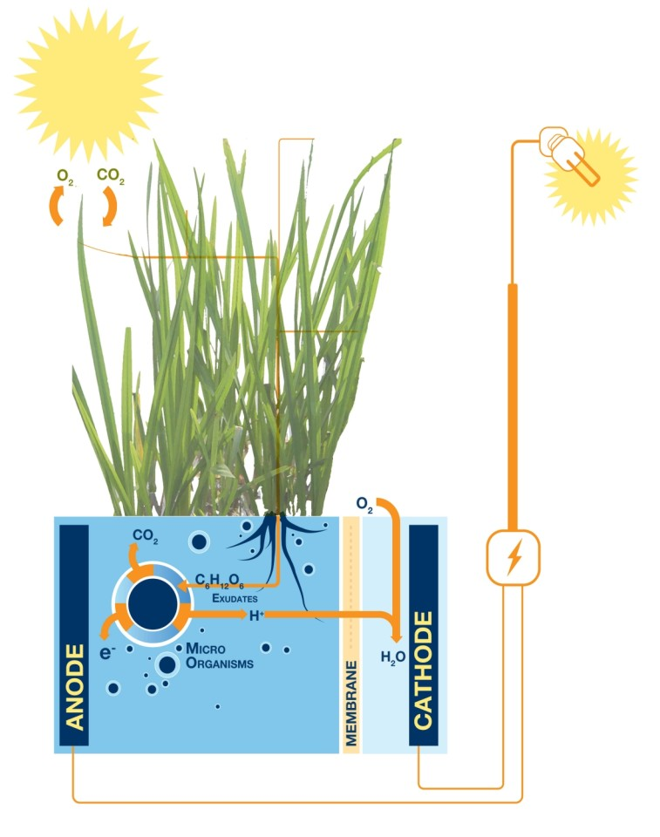
Figure 3 - Concept of PMFCs [4]
Role of Plants. Plants photosynthesize to yield organic matter (O.M.), which serves as the carbon source in the rhizosphere for EAB activity. The plants are productive in the removal of pollutants and heavy metals from ecosystems. Likewise, plants serve as an indicator species from the health of an ecosystem. The deployment of plant ecosystem remediation is well established. There are four types of plants used in the construction of PMFCs: vascular plants, macrophytes, wetland or marshy land grasses, and bryophytes. Wetland plants are commonly used in the construction of biocathodes. This plant type is water tolerant and possesses aerenchyma tissues that easily allow O2 from the atmosphere into the roots [4]. The selection of plants is typically made casually. However, the selection of the suitable species increases the desired treatment and bioelectricity generation. Locally available species are preferred to avoid the introduction of invasive species [4].

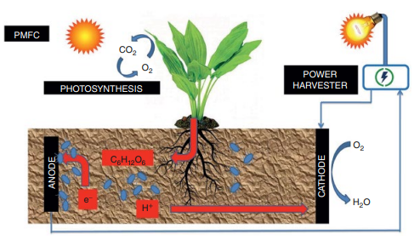
Figure 4 - Schematic overview of PMFCs [5]
The two significant factors in PMFC plant selection are plants that produce a more considerable quantity of exudates and plant species with C4 photosynthetic pathways. The magnitude of bioelectricity generated is directly related to the number of exudates produced. Also, C4 plants have higher rates of solar conversion and efficiency [4]. Thus, increased rhizodeposition is produced that can serve as a substrate for microbial oxidation. The other considerations for PMFCs plant selection are hardness, growth rate, microbial community, the extensiveness of the roots, tolerance and bioaccumulation abilities, and local adaptability. Spartina Anglica implanted PMFC achieve the highest power generation while removing pollutants. Rice cultivars are the most preferred plant species with easy access, adequate hardness, and flexibility to grow under different conditions within various ecological zones [6].

Figure 5 - Left - C4 plants, Right – Bryophytes (non-vascular) [7]
Supporting Matrix. The supporting matrix is the equivalent in the PMFC operation of electrolytes in standard fuel cells. The supporting matrix is considered during the design and operation since the matrix affects the internal resistance. Increased internal resistance impedes the migration of protons (H+) between the electrodes, the diffusion of root exudates to the anode. The types of supporting matrix used in PMFC operation include flooded soils, paddy, wetland or garden soils, sediments, vermiculite, and graphite granules in which the anode and the living plant are buried. Soils are the common supporting matrix because of the presence of rich natural microbes. In the supporting matrix, the rhizosphere provides substrates (carbon) for the growth of rhizobacterial populations. The microbiome of the rhizosphere plays a vital role in the soil microenvironment. Exudates stimulate chemotaxis, which increases soil microorganisms in the rhizosphere. About 70% of the carbon deposited by photosynthesis is translocated into the soil as rhizodeposition. Almost 60% of it can be recovered as energy by PMFCs [6].

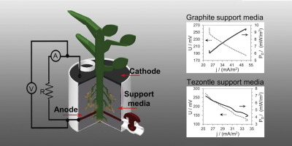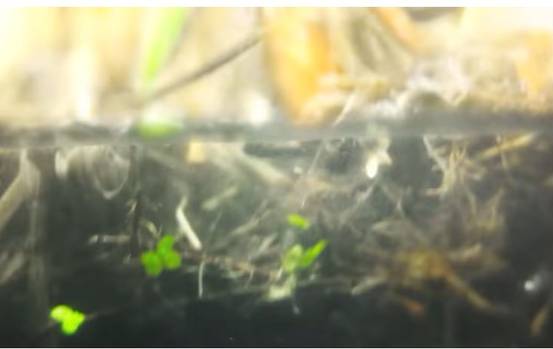
Figure 6 - Left - cross-section of supporting matrix, Center - soil matrix, Right - flooded soil matrix [5]
Microorganism in the Rhizosphere. The rhizosphere is the region extending about 4 mm around the roots. This area is where electrodes are inserted during PMFC operation. The rhizosphere supports a wide range of microbes and microbial activities. The rhizodeposits provide surfaces for bacterial attachment. The PMFCs microbial communities are different. Root exudates differ between plant species. Microbial communities vary with supporting matrix or operation conditions [8].

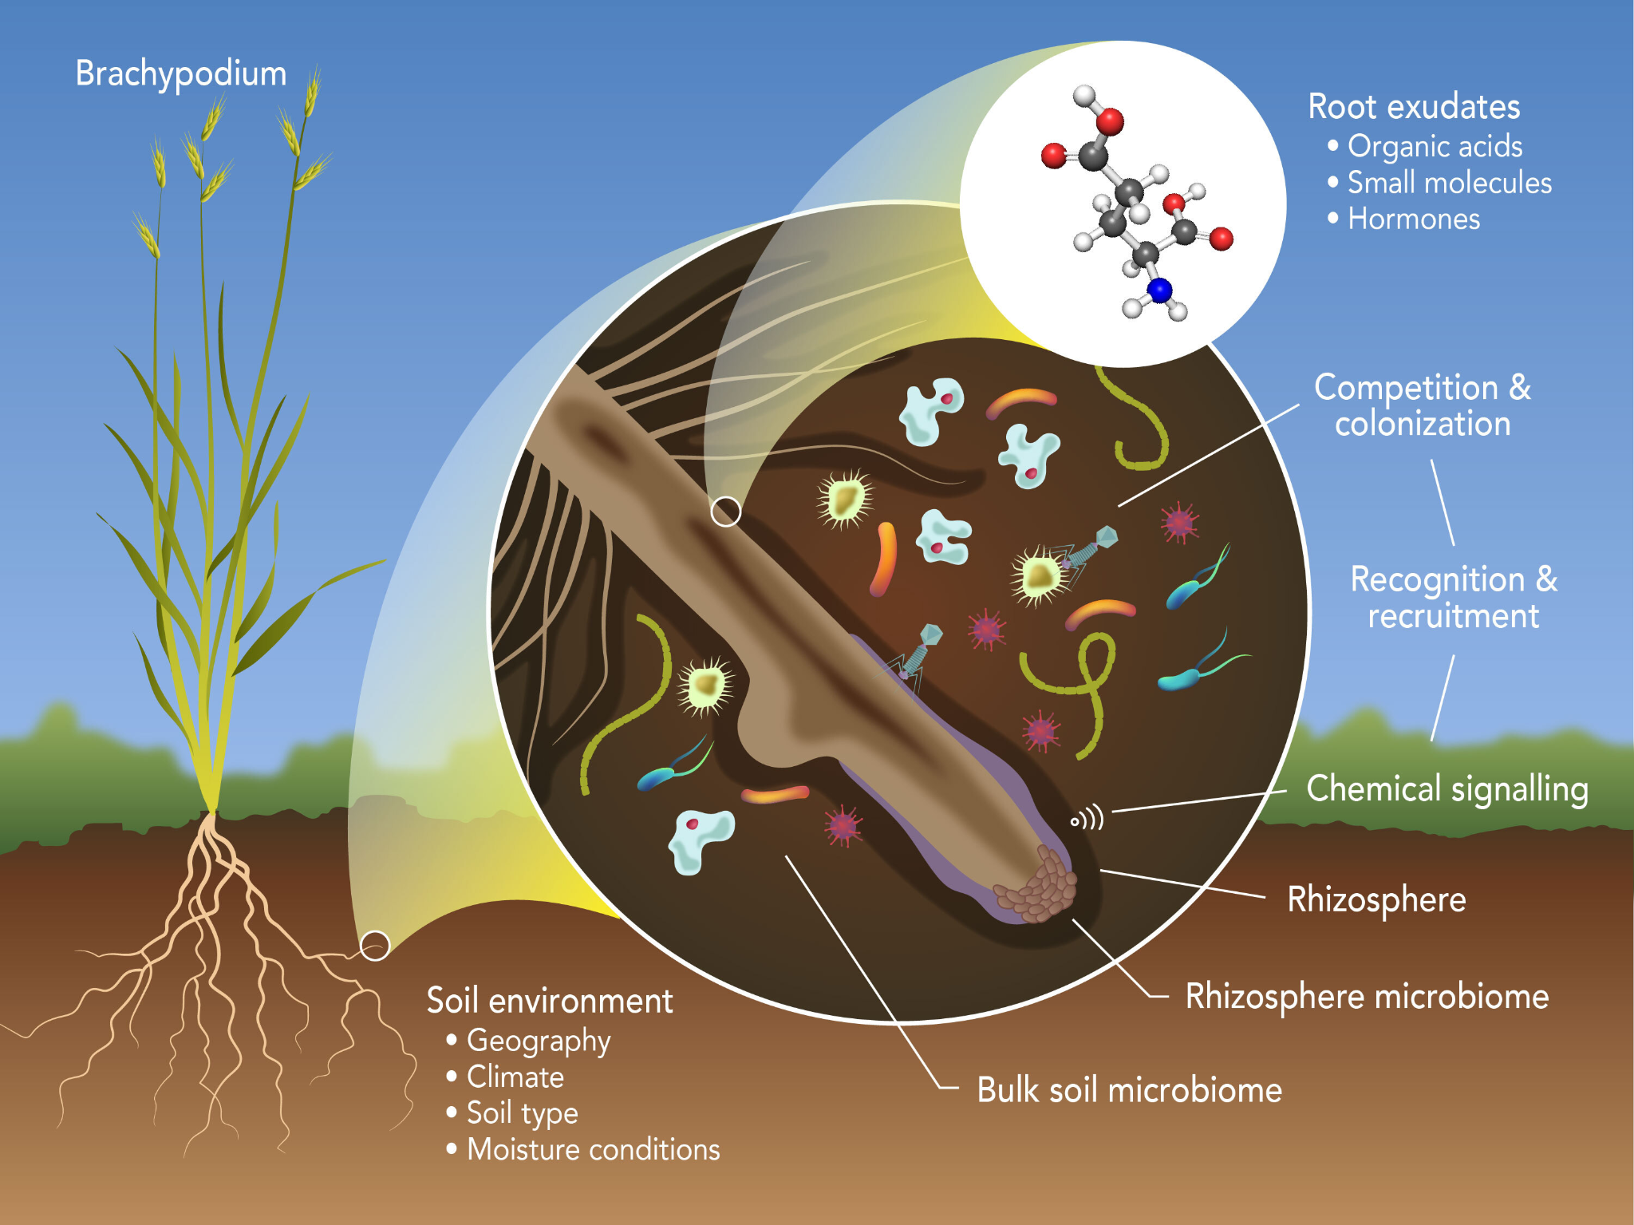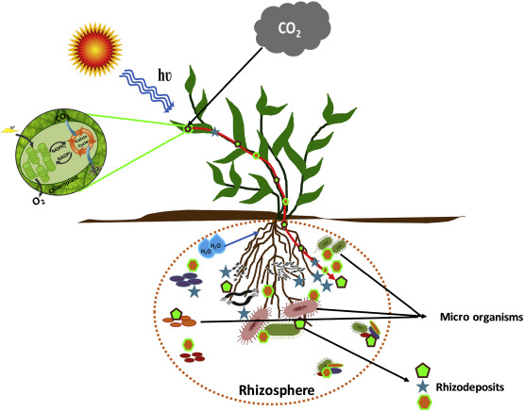
Figure 7 - Close-ups of microbes in the rhizosphere [8]
Substrate conversion. The Organic matter (O.M.) in the supporting matrix serves as the substrate and energy source for EABs during PMFC operation. Several other reactions occur:
- chemical oxidation of microbially produced reductants
- microbial oxidation of Sulphur to sulfate
- oxidation of ammonia to nitrite/nitrate
- conversion of carbonate into organic carbon
- hydrolysis of carbohydrates to acetate
All these reactions produce electrons which are transferred to the anode for bioelectricity generation [8].

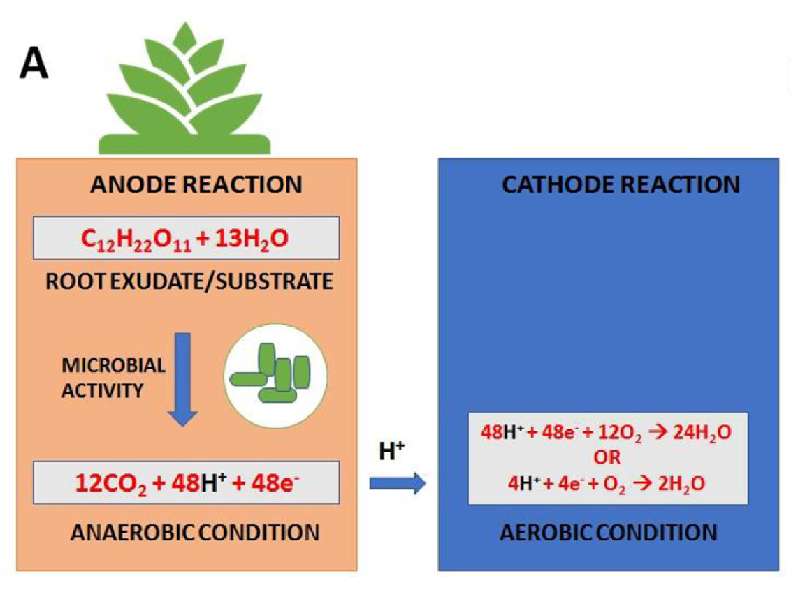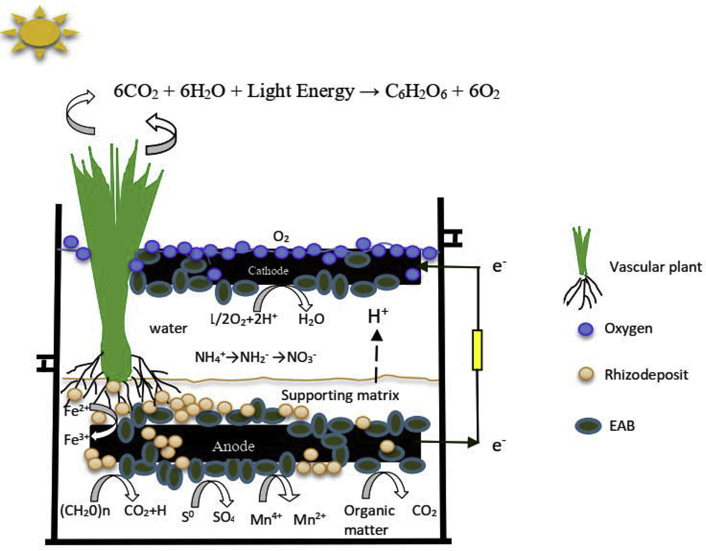
Figure 8 - Left - depiction of anode and cathode reactions, Right - substrate reactions contributing electrons [8]
Electron transfer. The process begins with rhizodeposition from the plant's photosynthetic activity. The microbes oxidize the rhizodeposits for growth in the process converts substrates into carbon dioxide (CO₂), protons (H+), and electrons (e–). These by-products are donated to the anode. The electrons (e-) captured by the anode are transferred externally to the cathode creating electricity. The proton (H+) travels the medium to the cathode. The combination of proton and electron flow creates an electrochemical potential across the medium that drives the process. At the cathode, oxygen is reduced to water as a by-product. The transfer of electrons to the anode has three pathways: (i) direct electron transfer by biofilm-forming bacteria (Fig. 9a) (ii) mediated electron transfer (Fig. 9b) (iii) electron transfer through nanowires (Fig. 9c). The supporting matrix can also serve as an electron donor, especially in wastewater systems [6].

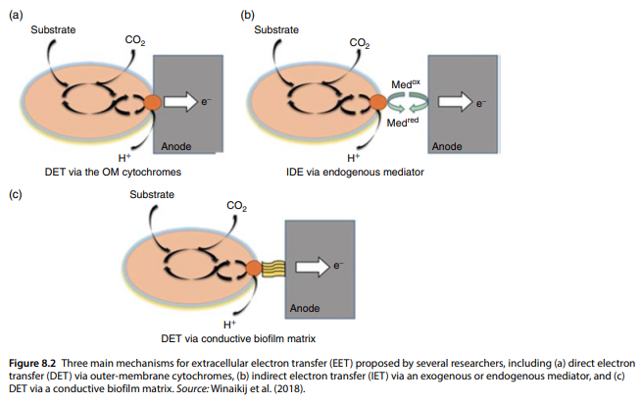
Figure 9 - depiction of three methods for electron transfer in PMFCs [6]
APPLICATIONS FOR PMFCS

Wastewater remediation. PMFCs bioelectricity generation from wastewater demonstrated by Mohan et al. using a miniature floating macrophyte ecosystem to generate bioelectricity using domestic sewage and fermented distillery. The research group determined that the PMFC removed COD (86.67%) and VFA (72.32%) and had bioelectricity generation of (224.93 mA/m2) [9].

Greenhouse Gas Mitigation. PMFCs are installed in wetlands and paddy fields to reduce methane gas emissions [9].

Biosensing. Fuel cells to power devices for detection of environmental pollutants in remote areas without electricity access. PMFC constructed to serve as a source of energy and biosensor for a wireless electronic system produced maximum voltage output of 502 mV and maximum current of 590 μA [9].

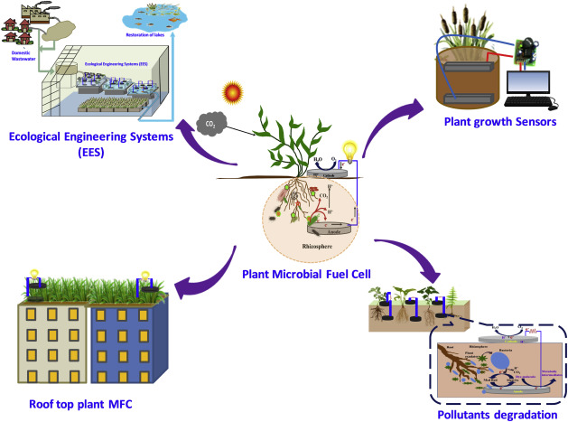
Figure 10 - Applications for PMFCs [8]

DESIGNS FOR PMFCs

Two significant designs have evolved for PMFCs. The initial PMFC design was the tubular setup. More recently, the flat-plate design is prevalent. The flat-plate design architecture allows for a greater shared surface area between the anode and cathode. Additionally, the flat-plate design means electrons and protons have a shorter distance to travel between the electrodes and helps mitigate the internal resistance. This concept means that more electrons are successfully transferred during operation [4].

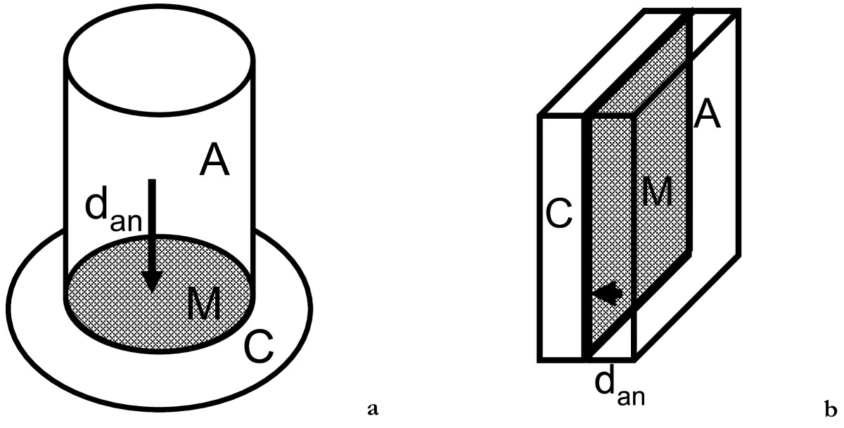
Figure 11 - PMFC designs - left - tubular, right - flat-plate [4]

HOW MUCH BIOELECTRICITY GENERATION?

Plants are inefficient at converting solar energy into biomass
● Quantum factors affecting photosynthesis
● Chloroplasts only absorbs light in the 400-700 nm band
● Accounts for about 45 percent of incoming solar radiation [10]

C3 and C4 two most prevalent photosynthesizing plants (named from number of carbon atoms in the first molecules they form during CO₂ breakdown)

Theoretical conversion limit:
● C3 plants (95% plants on Earth) = 4.6 % [10]
● C4 plants = 6 % [10]
These plants achieve only 70 % of theoretical conversion limit [10]

Any machine loses some energy in running the works. For PMFCs energy is lost in growing the plant:
● Only 20 % of biomass from photosynthesis reaches the rhizosphere [10]
● Only 30 % of that becomes available to microbes as food [10]
PMFCs convert 9 % of the energy from microbial metabolism as electricity [10]

Therefore, PMFC solar-to-electrical conversion rate:
● for C3 plants = (70 %) x (4.6 % conversion rate) x (20 %) x (30%) x (9 %) = 0.017 %
● for C4 plants = (0.70 x 6.0 x 0.20 x 0.30 x 0.09) = 0.022 %

How much energy they can PMFC produce?

- According to a 2008 estimate 21 gigajoules (5,800 kilowatt-hours) per hectare (2.5 acres) each year [11]
- Estimated that number could go as high 1,000 gigajoules per hectare [11].
- Europe has approximately 13.7 million farmers each farm averaging 12 hectares (29.6 acres) [11]
- America has 2 million farmers averaging 180 hectares (444.6 acres) [11]

If 1 % of U.S. and European farmlands were converted to PMFCs:
● Europe: generate 34.5 million gigajoules (9.58 billion kilowatt-hours) annually
● America: generate 75.6 million gigajoules (20.9 billion kilowatt-hours) annually

PMFC EXAMPLES

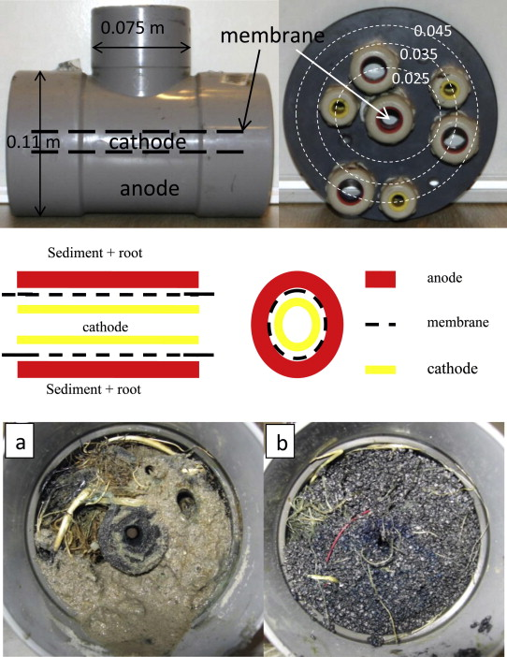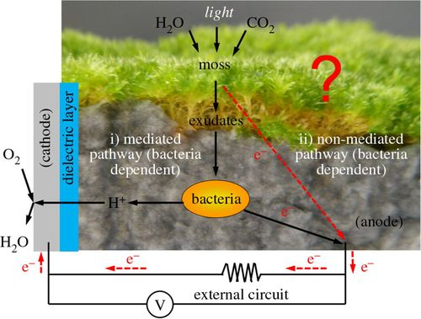
Figure 12 - Different PMFC setups. Left - tubular. Right - PMFC using moss (non-vascular) [11] [12] [13]
PROSPECTS FOR PMFCs

PMFCs provide continuous sustainable bioelectricity generation without harvesting the plant. The plants produce stable power all year round. These systems can be coupled to power biosensing devices to monitor ecological quality in remote areas without electricity access. PMFCs can be deployed to remediate ecosystems in addition to electricity generation. Plant-e is currently commercializing PMFCs for green roofs. PMFCs could add aesthetic value to parks and gardens or used indoor to improve air quality in an urban setting. Singapore's Eco-City demonstrated the beauty of plant integration into an urban setting. One significant advantage, PMFCs are fully functional in wetlands areas unsuitable for food production and in wastewater. PMFCs can generate sustainable green energy with living plants as the only source of organic matter (O.M.).

CHALLENGES FOR PMFCs

PMFCs face several challenges to optimize operational conditions for commercial applications. The best performing PMFCs produce low power output compared to the theoretical limit. The estimated net power output is 3.2 mW m−2 per geometric planting area (280,000 kWh ha−1 year−1) [4]. Scientists must overcome the O.M. limitation for EAB oxidation and higher internal resistance at the anode to improve power output. Further, improvement requires researchers to find plant species with increased rhizodeposition and EABs with a high metabolic ability (extracellular electron transfer) [8].

CONCLUSION

Quote from the New York Times [14]:

“Directly or indirectly nearly all life on Earth is solar-powered

Plants convert sunlight into organic compounds that, when consumed by other life, pass on the sun's energy to the rest of the food web. As humans, we access this stored energy through digestion and by burning raw or processed plants. Petroleum is just long-dead organic matter transformed by geological forces, and first-generation biofuels are ginned up from corn, sugar cane and vegetable oil.

Unfortunately, petroleum is as packed with environmental and security problems as it is energy, and first-generation biofuels -- which are refined by burning other fuels -- fall well short of carbon neutrality. Worse, as global food crops literally lose ground to biofuel production, mounting scarcity drives up food prices, hunger and political instability.

But what if there were a way to have our rice and burn it, too? What if we could derive energy from crops without killing them, or generate power using plants and land not needed for food, all through the power of microbes? That's the idea behind plant-microbial fuel cells (PMFCs).”

PMFCs are capable of remediating polluted ecosystem and generating bioelectricity. However, they have low power output compared to the theoretical estimated net power output of 3.2 mW m⁻² per geometric planting area (280,000 kWh ha−1 year−1). Several improvement in the performance of PMFC can be achieved by using plant species with high rhizodeposition output, higher metabolic EABs, and optimizing the system to the operational conditions. PMFCs will become an alternative bioelectricity generation process to solve the problems of energy scarcity and related environmental deterioration.

CITATIONS

[1] D. Gielen, F. Boshell, D. Saygin, M. D. Bazilian, N. Wagner, and R. Gorini, “The role of renewable energy in the global energy transformation,” Energy Strategy Rev., vol. 24, pp. 38–50, 2019, doi: https://doi.org/10.1016/j.esr.2019.01.006.
[2] “Without electricity, 1.3 billion are living in the dark,” Washington Post. http://www.washingtonpost.com/graphics/world/world-without-power/ (accessed May 07, 2021).
[3] “Plant-e | Spark of Nature,” Plant-e. https://www.plant-e.com/en/ (accessed May 07, 2021).
[4] M. Helder et al., “Electricity production with living plants on a green roof: environmental performance of the plant-microbial fuel cell,” Biofuels Bioprod. Biorefining, vol. 7, no. 1, pp. 52–64, 2013, doi: https://doi.org/10.1002/bbb.1373.
[5] P. Chiranjeevi, D. K. Yeruva, A. K. Kumar, S. V. Mohan, and S. Varjani, “Chapter 3.8 - Plant-Microbial Fuel Cell Technology,” in Microbial Electrochemical Technology, S. V. Mohan, S. Varjani, and A. Pandey, Eds. Elsevier, 2019, pp. 549–564.
[6] R. Shaikh et al., “Bioelectricity production using plant-microbial fuel cell: Present state of art,” South Afr. J. Bot., Oct. 2020, doi: 10.1016/j.sajb.2020.09.025.
[7] K. Wetser, E. Sudirjo, C. J. N. Buisman, and D. P. B. T. B. Strik, “Electricity generation by a plant microbial fuel cell with an integrated oxygen reducing biocathode,” Appl. Energy, vol. 137, pp. 151–157, Jan. 2015, doi: 10.1016/j.apenergy.2014.10.006.
[8] F. T. Kabutey et al., “An overview of plant microbial fuel cells (PMFCs): Configurations and applications,” Renew. Sustain. Energy Rev., vol. 110, pp. 402–414, Aug. 2019, doi: 10.1016/j.rser.2019.05.016.
[9] Q. Wu, S. Jiao, M. Ma, and S. Peng, “Microbial fuel cell system: a promising technology for pollutant removal and environmental remediation,” Environ. Sci. Pollut. Res., vol. 27, no. 7, pp. 6749–6764, Mar. 2020, doi: 10.1007/s11356-020-07745-0.
[10] H. Deng, Z. Chen, and F. Zhao, “Energy from Plants and Microorganisms: Progress in Plant-Microbial Fuel Cells,” ChemSusChem, vol. 5, no. 6, pp. 1006–1011, Jun. 2012, doi: 10.1002/cssc.201100257.
[11] R. A. Timmers, D. P. B. T. B. Strik, H. V. M. Hamelers, and C. J. N. Buisman, “Long-term performance of a plant microbial fuel cell with Spartina anglica,” Appl. Microbiol. Biotechnol., vol. 86, no. 3, pp. 973–981, Apr. 2010, doi: 10.1007/s00253-010-2440-7.
[12] P. Bombelli et al., “Electrical output of bryophyte microbial fuel cell systems is sufficient to power a radio or an environmental sensor,” R. Soc. Open Sci., vol. 3, no. 10, p. 160249, doi: 10.1098/rsos.160249.
[13] “Flora Health Wireless Monitoring with Plant-Microbial Fuel Cell,” Procedia Eng., vol. 168, pp. 1646–1650, Jan. 2016, doi: 10.1016/j.proeng.2016.11.481.
[14] “How Plant-microbial Fuel Cells Work,” HowStuffWorks, Jan. 17, 2013. https://auto.howstuffworks.com/fuel-efficiency/alternative-fuels/plant-microbial-fuel-cell.htm (accessed Apr. 28, 2021).

