Non-flammable Electrolytes for Li-ion Batteries (LIB)

Dong Ok Kim
Department of Chemistry, University of Illinois at Urbana-Champaign, Urbana, IL 61801 USA
NPRE 498: Energy Storage systems, Fall 2023

Abstract: Li-ion batteries (LIBs) are the key technology for electrification of vehicles. However, their dependence on organic liquid electrolyte makes them prone to thermal run away. While organic liquid electrolyte allows LIBs to have high energy density, it is volatile and flammable. Recent studies have discovered electrolytes for LIBs that are non-flammable. This paper discusses four different non-flammable liquid electrolytes with high thermal stability that can replace more conventional organic electrolytes.

KEY WORDS: Li-ion batteries, liquid electrolytes, thermal run away, non-flammable electrolytes

INTRODUCTION
Li-ion batteries (LIB) have become a key technology for electrification of vehicles due to the combination of high specific energy and power. However, the safety hazards associated to LIB limits its broad adoption in long-range electric vehicles. Conventional LIB utilizes organic liquid electrolytes due to their high ionic conductivities and wide electrochemical window that is not limited by oxygen evolution reaction and hydrogen reduction reaction (Figure 1). However, non-aqueous carbonate-based organic solvents have low boiling points and high flammability, making LIB prone to thermal runaway (Figure 2). Mechanical abuse such as car crashes or electrical abuse including internal short circuits can generate heat to raise the temperature of the system and initiate fire.
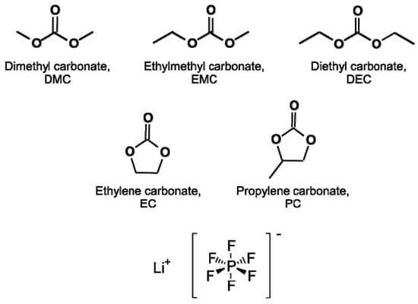
Figure 1. Molecular structures of conventional organic solvents for LIB electrolytes
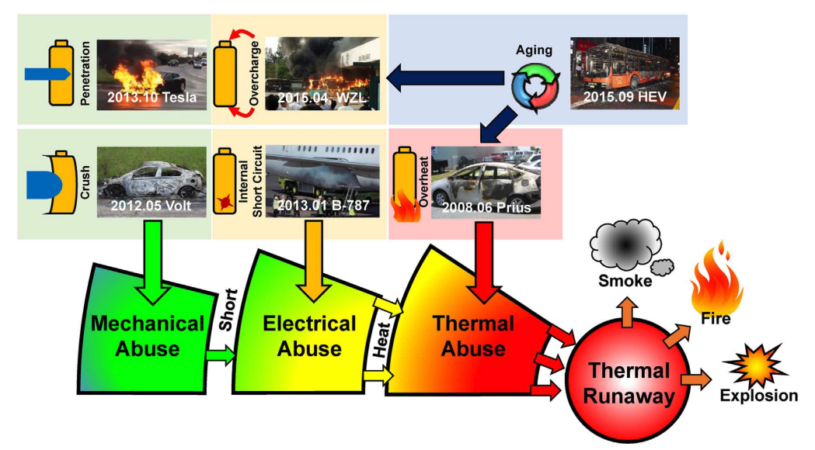
Figure 2. Abuse conditions of Li-ion batteries and the resulting thermal runaway
Alternatively, people have studied different ways to design non-flammable liquid electrolytes. This report will introduce four different liquid electrolyte systems that are non-flammable.

FLAME RETARDANTS
Phosphorous containing organic molecules are widely adopted flame retardants. They are co-solvents that can be added to the conventional liquid electrolyte system. In 2018, Shi et al. reported trimethyl phosphate (TMP) as an efficient flame retardant with low toxicity and volatility. When it was added to an electrolyte composed of 5 M lithium bis(fluorosulfonyl)imide (LiFSI), it demonstrated significantly improved thermal stability compared to a conventional electrolyte of 1 M lithium hexafluorophosphate (LiPF₆) in ethylene carbonate (EC)/diethyl carbonate (DEC) (Figure 3). However, phosphate-based electrolytes do not completely remove the flammability from the system because they are also organic molecules. In addition, they have poor oxidative stability which makes them incompatible with graphite electrode. Graphite electrode is the anode that is adopted in most commercial LIBs due to its high capacity and thermodynamic stability. Therefore, incompatibility with graphite electrode is a critical
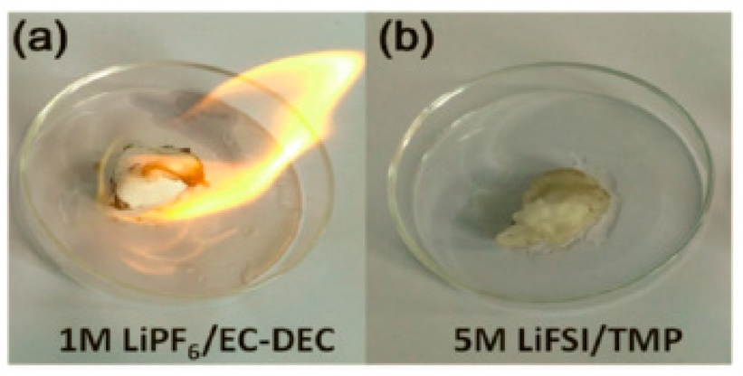
limitation of phosphate-based electrolytes.
Figure 3. Flammability test of 1M LiPF6/EC-DEC and 5M LiFSI/TMP

Fluorinated solvents are another type of flame retardants. They have additional fluorinated methyl groups attached to conventional electrolyte solvents for LIBs. An electrolyte system composed of 1.0 M LiPF6 in propylene carbonate (PC): methyl(2,2,2-trifluoroethyl)carbonate (FEMC):di-(2,2,2-trifluoroethyl)carbonate (DFDEC) in a 3:2:5 volume ratio was resistant to flame test in contrast to a conventional electrolyte with 1M LiPF₆ in ethylene carbonate (EC):ethyl-methyl carbonate (EMC) (Figure 4)¹. Fluorinated co-solvents also help improve the battery performance overall (Figure 5)¹. However, their high viscosity and low ionic conductivity can adversely affect the LIB performance. In addition, fluorinated solvents are generally more expensive compared to regular solvents due to the difficulty in synthesis process.
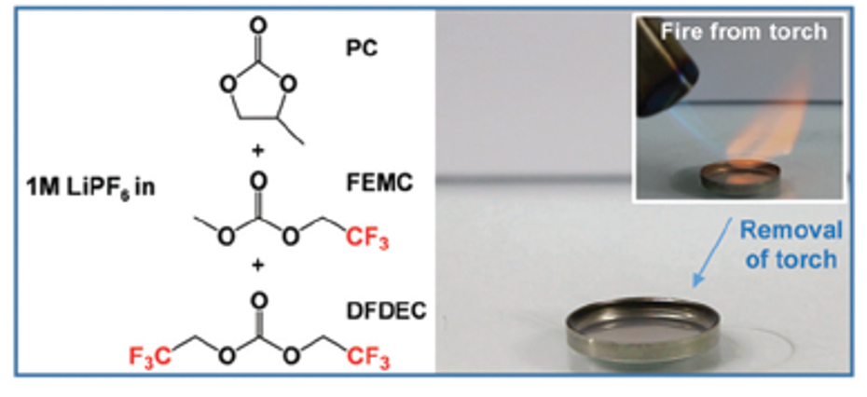
Figure 4. Fluorinated flame retardants and the flame test of the electrolyte consisting of 1.0 M LiPF₆/PC:FEMC:DFDEC
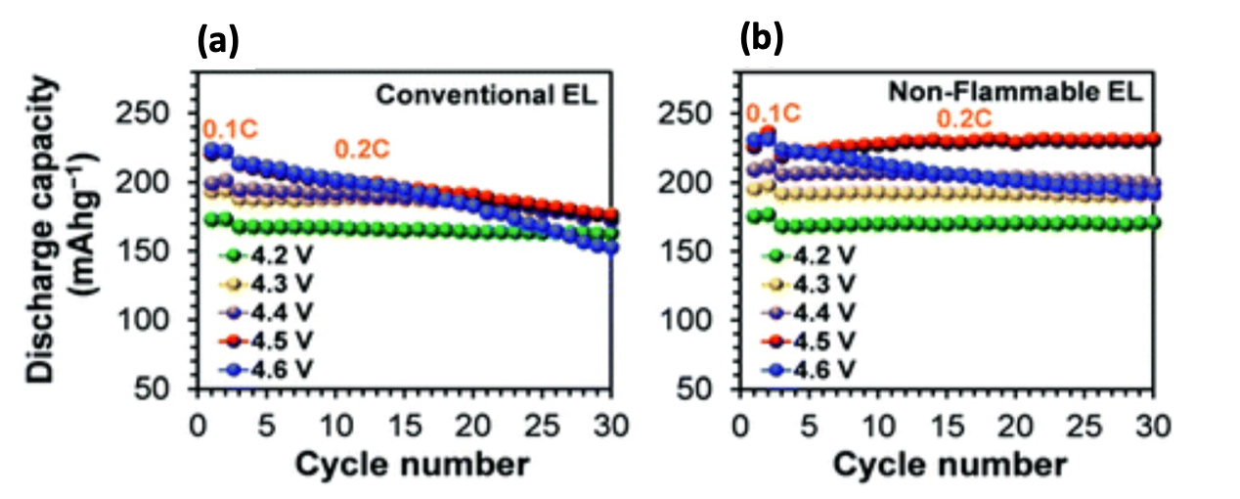
Figure 5. Discharge capacity at different charge cut-off voltages of Li//LiNi_{0.8}Co_{0.1}Mn_{0.1}O₂ half-cells with (a) conventional electrolyte and (b) non-flammable electrolyte consisting of 1.0 M LiPF₆/PC:FEMC:DFDEC

HIGHLY CONCENTRATED ELECTROLYTES
While the concentration of conventional LIB liquid electrolyte is 1M, increasing the concentration of salt can reduce the flammability of the electrolyte. Electrolyte with salt concentration higher than 4 M is considered as highly concentrated electrolyte (HCE). In HCE system, significant amount of electrolyte is non-combustible salt which increases its thermal stability (Figure 6)². Furthermore, HCE is reported to improve battery performance overall due to the stable electrolyte-electrode interface. The highly stable and inorganic interface can be attributed to the high anion concentration in the electrolyte^{2,3}. 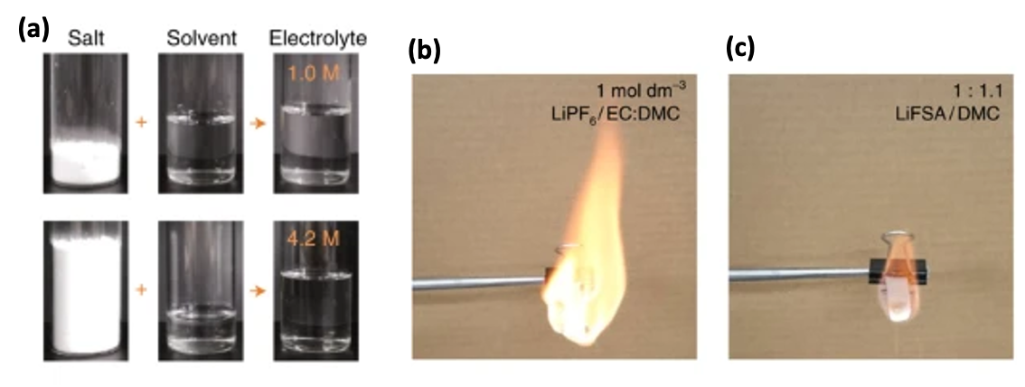
Figure 6. (a) photographs of dilute and concentrated electrolytes and their corresponding salt and solvent. Flame tests of a (b) commercial dilute electrolyte and (c) superconcentrated electrolyte.
However, the high viscosity of HCE decreases the ionic conductivity and wettability which could contribute to the high resistance during initial cycles³. Furthermore, salt is what costs the most among the electrolyte components.

Localized (diluted) high concentrated electrolytes (LHCEs) are the systems that were recently introduced to overcome the limitations of HCEs. LHCE includes an inert diluent that does not solvate the lithium ions in the electrolyte system. The diluents are usually hydrofluoroethers (HFEs) such as bis(2,2,2-trifluoroethyl) ether (BTFE) and 1,1,2,2-tetrafluoroethyl-2,2,3,3-tetrafluoropropyl ether (TTE)³. Due to the weak solvation ability of the diluents, the LHCE system consists of locally formed highly concentrated electrolyte structure (Figure 7). Eventually, LHCE resembles HCE system without using as much salt and forming less viscous electrolyte. However, HFEs can be flammable as well which makes LHCE not completely safe. In addition, HFEs are molecules with many fluorinated groups, thus contributing to environmental issue. Recently, there have been many studies that adapted non-fluorinated molecules as diluents of LHCE⁴. Development of non-fluorinated solvents that are highly efficient in forming LHCE should be pursued further.
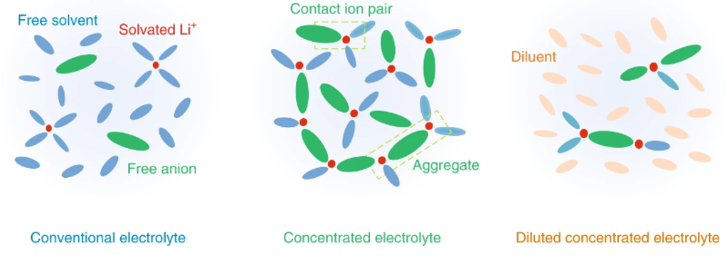
Figure 7. Schematics of solvation structures of the three electrolytes: conventional electrolyte, concentrated electrolyte, and diluted concentrated electrolyte

IONIC LIQUIDS (ILs)
Ionic liquids are molten salts with melting points below 100 ºC. The salts are composed of organic cations and inorganic/organic anion. The weak coulombic interaction between ions is what makes the melting point low enough. Anions and cations can be freely combined depending on their applications which makes them very versatile (Figure 8)⁵. They demonstrate high thermal stability which can be attributed to the low vapor pressure. Yang et al. studied physicochemical properties of pyrrolidinium-based ILs and compared them with a conventional carbonate-based electrolyte⁶. The IL system that was tested was N-propyl-N-methylpyrrolidiniumbis (trifluoromethanesulfonyl) imide (PYR₁₃TFSI) in EC/DMC based electrolyte. Different types of electrolytes were made with varying concentrations of PYR₁₃TFSI. The flammability test supported that ILs have good thermal stability. Specifically, thermal gravimetric analysis (TGA) exhibited two step decomposition where earlier decomposition can be attributed to the EC/DMC organic solvents (Figure 9). which was compared against Generally, ILs have superior ionic conductivity and electrochemical stability because they are completely composed of anions and cations. However, their properties can be tuned using different types of anion or cation pairings.

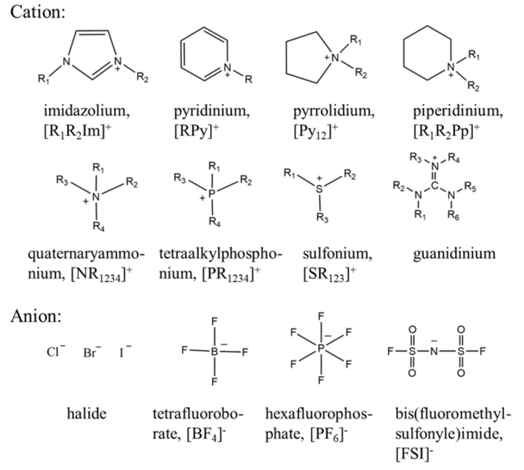
Figure 8. Anions and cations of the molten salts used for ILs
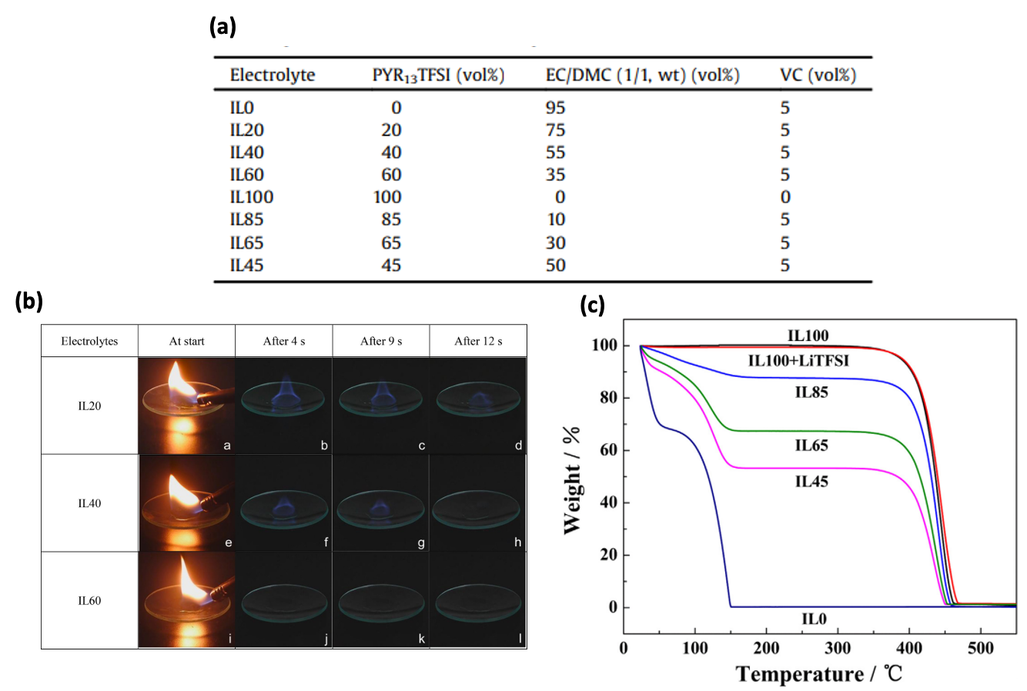
Figure 9. (a) The compositions of the mixed electrolytes with Pyrrolidinium-based salt and conventional solvents (b) Flame tests on the IL20 electrolytes (c) TGA curves of all the electrolytes in the Figure 8a.

AQUEOUS ELECTROLYTE
Most obvious alternative of flammable organic solvents is aqueous electrolyte. While organic solvents are highly flammable, water is not flammable which increases the thermal stability of LIB system overall. However, as discussed earlier, using water as a solvent has been avoided due to its electrochemical side reaction. The electrochemical window of water-based electrolytes is typically limited to 1.23 V due to hydrogen reduction reaction and oxygen evolution reaction⁷. The previous aqueous battery that utilized LiMn₂O₄ was able to reach 2.0 V, which is still narrower than the system with organic electrolyte. However, in 2015, Suo et al. reported a 3.0 V aqueous lithium-ion battery⁷. They named the system “water-in-salt” because of the very high concentration of salt used in the system—20 m lithium bis(trifluoromethane sulfonyl)imide (LiTFSI) salt in water. High concentration of salt induced the formation of inorganic-rich, stable electrode-electrolyte interface. Such interface effectively reduced the electrochemical activity of water. With the reduced side reactions of oxygen and hydrogen at the electrode surfaces, Suo et al. was able to expand the electrochemical window to 3.0 V (Figure 10). However, the main drawback of using aqueous electrolytes is the limitation of type of anode that can be utilized in the system. Aqueous electrolytes have poor stability at energy dense anode materials such as silicon, graphite, and Li metal, resulting in low capacity. These anode materials require even wider electrochemical window, where aqueous electrolyte starts breaking down. When the electrolyte reaches the potential that these anode materials require, hydrogen evolution reaction happens and disrupts a stable interphase formation.
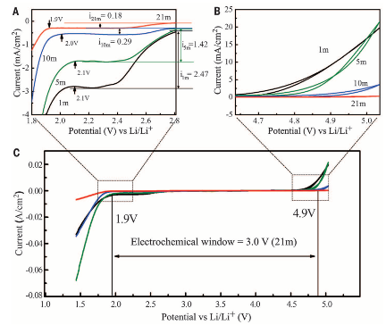
Figure 10. The electrochemical stability window of the aqueous electrolyte on stainless steel electrodes

CONCLUSION
In conclusion, conventional organic electrolytes for lithium-ion batteries involve numerous safety hazards such as thermal runaway. Studies have reported different types of non-flammable electrolytes including non-flammable additives, high concentration electrolyte, ionic liquids, and aqueous electrolyte. Each method still has limitations that need improvement.

(1) Gond, R.; Van Ekeren, W.; Mogensen, R.; Naylor, A. J.; Younesi, R. Non-Flammable Liquid Electrolytes for Safe Batteries. Mater. Horiz. 2021, 8 (11), 2913–2928. https://doi.org/10.1039/D1MH00748C.
(2) Wang, J.; Yamada, Y.; Sodeyama, K.; Chiang, C. H.; Tateyama, Y.; Yamada, A. Superconcentrated Electrolytes for a High-Voltage Lithium-Ion Battery. Nat Commun 2016, 7 (1), 12032. https://doi.org/10.1038/ncomms12032.
(3) Yamada, Y.; Wang, J.; Ko, S.; Watanabe, E.; Yamada, A. Advances and Issues in Developing Salt-Concentrated Battery Electrolytes. Nat Energy 2019, 4 (4), 269–280. https://doi.org/10.1038/s41560-019-0336-z.
(4) Moon, J.; Kim, D. O.; Bekaert, L.; Song, M.; Chung, J.; Lee, D.; Hubin, A.; Lim, J. Non-Fluorinated Non-Solvating Cosolvent Enabling Superior Performance of Lithium Metal Negative Electrode Battery. Nat Commun 2022, 13 (1), 4538. https://doi.org/10.1038/s41467-022-32192-5.
(5) Liu, K.; Wang, Z.; Shi, L.; Jungsuttiwong, S.; Yuan, S. Ionic Liquids for High Performance Lithium Metal Batteries. Journal of Energy Chemistry 2021, 59, 320–333. https://doi.org/10.1016/j.jechem.2020.11.017.
(6) Yang, B.; Li, C.; Zhou, J.; Liu, J.; Zhang, Q. Pyrrolidinium-Based Ionic Liquid Electrolyte with Organic Additive and LiTFSI for High-Safety Lithium-Ion Batteries. Electrochimica Acta 2014, 148, 39–45. https://doi.org/10.1016/j.electacta.2014.10.001.
(7) Suo, L.; Borodin, O.; Gao, T.; Olguin, M.; Ho, J.; Fan, X.; Luo, C.; Wang, C.; Xu, K. “Water-in-Salt” Electrolyte Enables High-Voltage Aqueous Lithium-Ion Chemistries. Science 2015, 350 (6263), 938–943. https://doi.org/10.1126/science.aab1595.

