NPRE 498ESU
NPRE 498ESG
Energy Storage Engineering
Fall 2026
1. Please read the assigned-reading lecture-notes chapters.
2. Then answer the corresponding written assignment,
3. For questions about the assignments, please access the teaching assistants by email:
https://www.mragheb.com/NPRE%20402%20ME%20405%20Nuclear%20Power%20Engineering/talist.htm
4. Submit the corresponding written assignment through email to https://canvas.illinois.edu
5. Please use either the Word or pdf formats
6. In case of internet “rationing” (e. g. to health and government authorities), instability, or collapse through overload, please read the lecture notes and submit the corresponding assignments. Already-taken tests and submitted assignments would be used in assessing the final grade.

Threat of Nuclear War:
https://www.youtube.com/watch?v=HSC7Lp1nvx8
https://www.mragheb.com/Suggestions%20for%20New%20Students%20to%20Consider.pdf

Number | Date  Assigned | Due  Date | Description
1 | 8/24 | 9/31 | Reading Assignment  Preface  Written Assignment  Using the Ragone plot, compare the following energy storage options:  1. Pumped storage hydro,  2. Chemical Batteries.  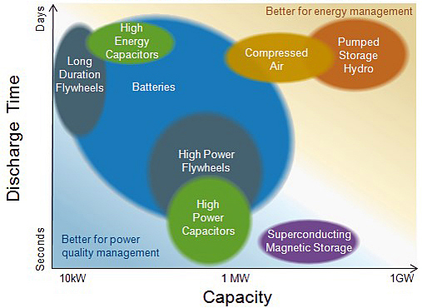  Using a Ragone plot version, compare the following energy storage options:  1. Chemical storage using Li-ion batteries,  2. Fuel cells using hydrogen as an energy carrier.
2 | 8/26 | 9/2 | Reading Assignment  Preface  Written Assignment  Using the table, estimate the needed rated power for a solar or wind energy installation to provide the power needs for a family of four in different countries, assuming the presence of a capability to store the energy in battery banks, an overall conversion efficiency of 30 percent, and an intermittence (capacity) factor of 40 percent for both wind and solar.  capita: person
  Country | Energy consumption  [kWe.hr / (capita.year)]
  USA | 12,878
  Japan | 7,432
  Switzerland | 7,206
  Germany | 6,027
  Hong Kong | 4,847
  China | 1,899
3 | 8/28 | 9/4 | Reading Assignment  Preface  Written Assignment  Draw a diagram showing the components of the envisioned Smart Grid or Interner of Things IoT for electrical power generation.  Construct a table showing the allocation of electrical energy production, storage (pumped), export and use on a given day in France in MWe and in the percentage of each energy source.  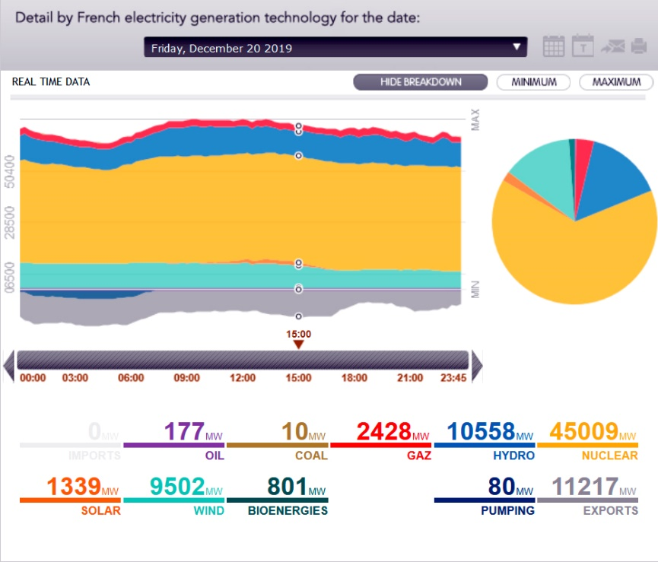
4 | 8/31 | 9/7 | Reading Assignment  Introduction  Written Assignment  List the characteristics of a viable Energy Storage System.  List the perceived advantages of energy storage in conjunction with Renewable and Conventional Energy systems.  An electrical storage battery is charged from a power supply at 1 kWe for an hour.  If its efficiency is 60 percent, how long would it take to totally discharge it if it is used to supply a load at 100 Watts(e)?
5 | 9/2 | 9/9 | Reading Assignment  Energy Storage Options  Written Assignment  List the main options under consideration to store energy.  To produce Hydrogen as an energy carrier, balance the thermo-chemical reactions used in the high temperature Iodine Sulfur (IS) hydrogen production process:  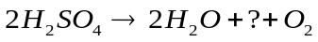  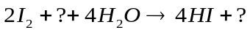  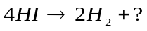  ________________________________  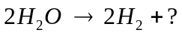
6 | 9/4 | 9/16 | Reading Assignment  2. Solar Thermal Power and Energy Storage Historical Perspective  Written Assignment  Henry E. Willsie identified the major weakness of all the previously built solar engines in their inability to overcome the intermittency problem of solar radiation. As an energy storage medium, he used large flat-plate collectors that heated water, which he kept warm all night in a large, insulated basin.  Identify the working medium that he used to extract the stored solar energy.  What was earlier pioneer Charles Tellier’ s choice?  What energy storage medium was used by Frank Shuman?
7 | 9/9 | 9/16 | Reading Assignment  2. Solar Thermal Power and Energy Storage Historical Perspective  3. Thermal Energy Storage  Written Assignment  In the Concentrated Solar Power (CSP) projects shown in the following table, calculate the  corresponding idealized Carnot Cycle efficiencies.  Rank the thermal energy storage media according to the achievable thermal cycle efficiency.
  Project | Type | Storage medium | Cooling loop | Nominal temperature  [ºC]
   |  |  |  | Cold | Hot
  Irrigation Pump  Coolidge, Arizona, USA | Parabolic Trough | Oil | Oil | 200 | 228
  IEA-SSPS  Almeria, Spain | Parabolic Trough | Oil | Oil | 225 | 295
  SEGS I  Daggett, California, USA | Parabolic Trough | Oil | Oil | 240 | 307
  Solar One  Barstow, California, USA | Central Receiver | Oil  Sand  Rock | Steam | 224 | 304
  CESA -1  Almeria, Spain | Central Receiver | Molten salt | Steam | 220 | 340
  THEMIS  Targasonne, France | Central Receiver | Molten salt | Molten salt | 250 | 450
  Solar Two,  Barstow, California, USA | Central Receiver | Molten salt | Molten salt | 275 | 565
8 | 9/11 | 9/18 | Reading Assignment  2. Solar Thermal Power and Energy Storage Historical Perspective  3. Thermal Energy Storage  Written Assignment  Calculate the theoretically achievable Carnot cycle efficiencies for the following liquid thermal energy storage media used in solar thermal applications  List the reflecting materials used in CSP applications.  List the choices of collector glazing materials in CSP applications.  Draw a diagram showing the favored energy storage strategy in CSP applications.
  Storage medium | Operational Temperature
  Storage medium | Cold  [ºC] | Hot  [ºC]
  Mineral oil, liquid petroleum (alkanes, cyclic paraffins, petroleum jelly) | 200 | 300
  Synthetic oil, polyalphaolefin, synthetic esters, hydrocracked/hydroisomerized base oils. | 250 | 350
  Silicone oil, polymerized siloxanes, …Si-O-Si-O-Si… | 300 | 400
  Nitrite salts, KNO₂, NaNO₂ | 250 | 450
  Nitrate salts, NaNO₃, KNO₃ | 265 | 585
  Carbonate salts, Na₂CO₃ | 450 | 850
  Liquid Na | 270 | 530
9 | 9/14 | 9/21 | Reading Assignment  4. Thermal Energy Storage with Solar Power Generation  Written Assignment  List then compare the options considered for Concentrated Solar Power Generation, CSP.  Define the Concentration Ratio CR in solar CSP applications.  List the types of tracking in CSP applications.
10 | 9/16 | 9/23 |  | Reading Assignment  7. Energy Hydrogenation and Decarbonization  Written Assignment  Write down the two half equations and their combination describing the operation of a typical fuel cell.
11 | 9/18 | 9/25 |  | Reading Assignment  7. Energy Hydrogenation and Decarbonization  Written Assignment  Compare the voltages generated by a single fuel cell element when it is operated at:  a. 20 ºC,  b. 100 ºC.  Use: 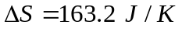,  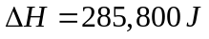,  F (Farady’s constant) = 96,487 [Coulombs] or [Joules/Volt], n=2.  What would the implication regarding cooling from the obtained different values?  How many full cells are needed for a 12-Volt battery?  How many full cells are needed for a 19-Volt battery?
12 | 9/21 | 9/28 |  | Reading Assignment  7. Energy Hydrogenation and Decarbonization  Written Assignment  Plot the graph describing the energy requirement for the electrolysis method for hydrogen production.  Discuss the effect on the overall process efficiency of:  1. Low temperature electrolysis,  2. High temperature electrolysis.  As a potential use of hydrogen, write a summary of the paper:  Rachel Beck and Magdi Ragheb, "Production of Carbon-Neutral Hydrocarbons From CO₂ and H₂ In Lieu of Carbon Capture and Storage (CCS)," 10th International Conference on "Role of Engineering Towards a Better Environment, RETBE14, Alexandria University, Faculty of Engineering, 15-17 December 2014.
13 | 9/23 | 9/28 |  | Reading Assignment  5. Battery Technology  6. Electric Vehicles Technology  Written Assignment  Define the following battery storage figures of merit:  1. Specific energy  2. Specific power  3. Energy density  Explain the difference between:  1. Primary batteries  2. Secondary batteries  Compare the different design options under consideration for a future fleet of Electrical Vehicles (EVs).  Describe the different usages of battery storage technology in:  1. Hybrid Electric Vehicles, HEVs,  2. Plug-in Hybrid Electric Vehicles, PHEVs,  3. Electric Vehicles EVs.
14 | 9/25 | 9/28 |  | Reading Assignment  6. Electric Vehicles Technology  8. Steam Reforming  Written Assignment  List three differences between ICE and EV propulsion.  Write a paragraph about fuel cell driven vehicles.  Compare the specific energy content of hydrogen and lithium-ion batteries.  Compare the specific energy content of hydrogen and of lithium-ion batteries as energy storage media in automotive energy storage options.  Compare a vehicle weight using hydrogen fuel cell vs. Li-ion batteries as a function of the attainable cruising range.  What approach is favored for the heavy trucking industry?  Compare the material compositions (in addition to Li) of the following Li -ion batteries:  1. LCO  2. NCA  3. LMO  4. NMC  How do the LCO batteries differ from the other types?  Briefly describe the steam reforming process for producing hydrogen.
 | 9/28 | Monday |  |  |  | First Midterm Exam, during class period
15 | 9/30 | 10/7 |  |  | Reading Assignment  10. High Temperature Water Electrolysis for Hydrogen Production  11. Thermochemical Iodine Sulfur Process for Hydrogen Production  Written Assignment  Draw the cycle diagram for the steam reforming process for producing hydrogen from methane.  Draw the cycle diagram for he Iodine-Sulfur (IS) high temperature thermochemical production of hydrogen.  What compounds act as catalysts in the overall reaction?
16 | 10/2 | 10/9 |  |  | Reading Assignment  9. Carbon Dioxide Reforming  12. The Hydrogen Economy  Written Assignment  Draw the cycle diagram for the steam reforming process for producing hydrogen from methane. Write the corresponding chemical reactions equations.  In the Fischer Tropsch industrial process carbon monoxide is reacted with hydrogen to synthesize hydrocarbons. The synthesis conditions are at 150 bar and 700 K in the presence of a catalyst.  In the case of natural gas methane to liquids applications the suggested basic chemical reaction would be:  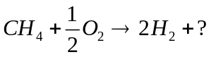  With Ni and Co used as catalysts, the following reaction would occur:  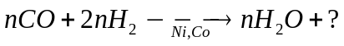  If, instead, a Fe catalyst is used the reaction proceeds as follows:  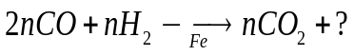
17 | 10/5 | 10/12 |  |  | Reading Assignment  32. Sustainable Global Energy, Desertec Concept  13. High Voltage Direct Current for Power Transmission  14. Smart Electrical Grid and Metering  Written Assignment  In order to meet today‘s global power demand of 18,000 TWh / year, it would suffice to equip about three thousandths of the world’s deserts, an area of about 90,000 km² with solar collectors of solar thermal power plants.  1. Calculate the fraction of the area of the Sahara Desert that this area would cover.  2. What is the cost of covering the electrical demands of North Africa and the Middle East as well as 15 percent of Europe’s electricity by 2050 in dollars and euros?  If Power is given as: P=IV.  Ohmic heating losses in conductors is H=I²R  Prove that high voltage V transmission of power is needed to minimize the ohmic heating losses in the conductors’ wires.  In what way does HVDC power transmission reduce the resistive heating losses compared with HVAC?  Explain and sketch two diagrams showing the advantages of HVDC over HVAC for the long-distance conveyance of electrical power from the perspectives of:  1. Capital costs,  2. Transmission energy losses as ohmic heating and corona discharge.
18 | 10/7 | 10/14 |  |  | Reading Assignment  26. Pumped Energy Storage  27. Pumped Storage in Association with the Red Sea to Dead Sea Peace Canal  Written Assignment  Consider a hydroelectric pumped energy storage facility producing power from stored sea water at a discharge rate of 39 m³/sec from a height of 500 m.  a) Calculate the theoretical rated power production of the station.  b) For a conversion efficiency of 85 percent, what would be the effective electrical power generation?  c) Calculate the potential yearly energy production in MWe.hrs.
19 | 10/9 | 10/16 |  |  | Reading Assignment  28. Pumped Storage Qattara Depression Solar Hydroelectric Power Generation  Written Assignment  Write a one-page summary of the paper:  Patricia Weisensee and Magdi Ragheb, "Integrated Wind and Solar Qattara Depression Project with Pumped Storage as Part of Desertec," The Role of Engineering Towards a  Better Environment, RETBE’12, 9th International Conference, Alexandria University, Faculty of Engineering, December 22-24, 2012.  Power Point Presentation.  Explain the economic advantages of the proposed approach in the paper to the earlier pumped energy storage project.
20 | 10/12 | 1/19 |  |  | Reading Assignment  31. Kinetic Energy Flywheel Energy Storage  Written Assignment  Consider a straight filament of length R and weight W rotating around a vertical spin axis with a rotational angular speed ω radians/sec.  1. Write the expression for the stored kinetic energy of the rotating element.  2. Derive the expression of its specific energy content.  3. What would happen to the stored kinetic energy if the rotational speed  a) is doubled,  b) is tripled.  Use for the moment of inertia for a thin rod: I = R²W/3g  What would be the choice material for the filament?
21 | 10/14 | 10/21 |  |  | Reading Assignment  29. Cryogenic Energy Storage  30. Compressed Air Energy Storage  Written Assignment
  Compare the energy input needs for the storage of Hydrogen in different forms:
  Compressed Hydrogen
  For the adiabatic compression of hydrogen, the compression energy in MJ/kg (1 MJ = 1,055 BTU) is:
  47 MJ/kg, for 10,000 psi
  36 MJ/kg, for 5,000 psi
  Liquefied hydrogen
  For cryogenic liquid hydrogen, the theoretical cooling energy expenditure is:
  2.94 MJ/kg, for gas from 25 ºC to 20 K
  0.45 MJ/kg, for gas to liquid at 20 K
  Total: 3.40 MJ/kg
  However, liquefaction involves a reverse Carnot Cycle efficiency of:
  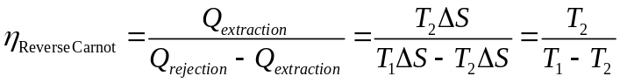
  For liquefaction from T₁ = 25 ºC = 25 +273 K= 298 K to T₂ = 20 K,
  This leads to actual liquefaction energies for a refrigeration efficiency of 7.19 percent of:
  Refrigeration energy = 3.4 / 0.0719 = 47.3 MJ/kg, for gas to liquid at 20 K
  Vaporization and warmup = 3.4 MJ/kg
  Total = ??? MJ/kg
22 | 10/16 | 10/23 |  |  | Reading Assignment  12. The Hydrogen Economy  15. Hydrogen Storage  Written Assignment  List the methods considered for the storage of hydrogen.  Give examples for the considered storage media.
23 | 10/19 | 10/26 |  |  | Reading Assignment  17. Primary and Secondary Storage Batteries  18. Battery Power Density, Life Cycle and Cost  Written Assignment  List the properties of a sound utility storage battery  Describe the main properties of LaNi₅H₆ as a hydrogen storage medium.  List some chemical hydrides used in hydrogen energy storage.  List some borohydrides used in hydrogen energy storage.
24 | 10/21 | 10/28 |  |  | Reading Assignment  17. Primary and Secondary Storage Batteries  24. Carbon Capture and Storage  Written Assignment  Compare the properties of:  - Li ion batteries  - Ni Cd batteries  Draw a diagram of the Proposed Oxy-Combustion coal technology for the Meredosia FutureGen 2.0 project.
25 | 10/23 | 10/30 |  |  | Reading Assignment  41. Algae Growth for Biodiesel Production  36. Battery and Fuel Cell Aircraft  51. Structural batteries  52. Gravitational Potential Energy Storage  53. Aerodynamic Solar Electric Vehicles  48. Salt Gradient Solar Pond  Trang Ha "Solar Pond for Desalination" pptx  Written Assignment  List the applications of solar ponds for solar energy storage.  Include a diagram of a proposed solar pond energy production cycle.  Identify the perceived advantages of the contemplated aerodynamic and solar electric vehicles.  Compare the electricity cost from gravitational potential energy storage to other energy storage choices.  Search the internet and then write a short description of recent European or USA fuel cell powered aircraft.  What are the perceived advantages of such a concept?  List the contemplated future uses and algae growth research.
26 | 10/26 | 11/2 |  |  | Reading Assignment  49. Quantum Glass Battery  50. Solid State Batteries  54. Recycling Electrical Vehicles Batteries  55. Flow Cell Batteries  Written Assignment  Describe the perceived advantages of suggested solid state batteries.  List the composition of glasses used in solid quantum glass batteries.  What are the main hazards encountered in recycling Li-ion batteries?  Draw a diagram of a flow battery.  List the advantages and disadvantages of flow batteries.
27 | 10/28 | 11/2 |  |  | Reading Assignment  35. Urea Power  33. Electrochemical Supercapacitor39. Ultra Capacitors Electrostatic Energy Storage  39. Ultra Capacitors Electrostatic Energy Storage  Written Assignment  The advantages and disadvantages of the use of supercapacitors in energy storage.
28 | 10/30 | 11/2
 | 11/2 | Monday |  |  | Second Midterm Exam, during class period
29 | 11/4 | 11/11
30 | 11/6 | 11/13
31 | 11/9 | 11/16
32 | 11/11 | 11/18
33 | 11/13 | 11/20
34 | 11/16 | 11/30
35 | 11/18 | 11/30
36 | 11/20 | 11/230
 | 11/23 |  |  |  | Fall Break
 | 11/25 |  |  |  | Fall Break
 | 11/27 |  |  |  | Fall Break
37 | 11/30 | 12/7
38 | 12/2 | 12/9
39 | 12/4 | 12/9
40 | 12/7 | 12/9
 | 12/9 | Last day  classes |  |  | Wed December 9, Final Exam during class period
 |  |  |  |  | 8:00-11:00 Wed December 16, Final Exam
12Assignments Policy
Assignments will be turned in at the beginning of the class period, one week from the day they are assigned.
The first five minutes of the class period will be devoted for turning in, and returning graded assignments.
Late assignments will be assigned only a partial grade. Please try to submit them on time since once the assignments are graded and returned to the class, late assignments cannot be accepted any more.
If you are having difficulties with an assignment, you are encouraged to seek help from the teaching assistants (TAs) during their office hours. Questions may be emailed to TA's, but face-to-face interaction is more beneficial.
Although you are encouraged to consult with each other if you are having difficulties, you are kindly expected to submit work that shows your individual effort. Please do not submit a copy of another person's work as your own. Copies of other people's assignments are not conducive to learning, and are unacceptable.
For further information, please read the detailed assignments guidelines.

