Structural Batteries as Energy Storage in Electric Vehicles

Tim Wallace
University of Illinois at Urbana-Champaign
NPRE 498: Energy Storage Systems
Professor M. Ragheb
7th May, 2020
- Introduction
Energy storage is one of the dominant drivers of human society. Modern life, with its fast communication, its accessible transportation and its comfort, relies mainly on a single category of energy storage - chemical fuel. Transportation is particularly reliant on fuel storage to perform at the level that is possible today. Most fuel storage systems are based on fossil fuels - coal, oil and natural gas. Fossil fuels are a finite resource and thus their price can fluctuate widely based on their availability. Nearly all fuel storage systems - with the exception of hydrogen - pollute the atmosphere to some degree. Biofuels still contribute to greenhouse gas emissions though less than fossil fuels.
An attractive alternative to fuel powered vehicles is electrical power. Electric motors have many advantages over their combustion engine counterparts. Portable electrical storage - batteries and supercapacitors - are the limiting technology for electric vehicles of all types. Existing battery technology cannot fit enough energy into a small enough space to compete with fuel powered vehicles. Structural batteries are a multifunctional component which incorporates energy storage into a structural member of a vehicle. The mass of a structural battery can effectively ‘disappear’ into the mass of a structural component. This review will survey structural batteries as an energy storage system. The current state of the technology will be assessed, as will its future potential.
- Background
In the United States, petroleum products - gasoline, diesel and kerosene - powered 88% of transportation in 2019 [1]. Only 3% of transportation energy storage systems in use were not fuel based [1]. Transportation accounts of 28% of the total energy used by the United States annually [1]. Fuel energy storage is particularly desirable for transportation applications because of its high energy density. Specific energy is the ratio of the energy stored to the weight of the storage medium. While the specific energy of petroleum based fuel is approximately 13 kWh/kg, the energy density of lithium ion batteries is approximately 83.3 Wh/kg - 100 times less [2].
$Specific Energy = \frac{Energy Stored in Battery}{Battery Mass}\left[\frac{Joule}{kg}\right]$ [1]

The low specific energy of batteries is the primary contributor to the limited range of electric vehicles (EV). Widespread adoption of EVs would require a major leap in battery technology. Innovative battery applications could provide more realistic solutions to the EV’s energy density problem. Embedded batteries are an intermediate step towards full multifunctional structural batteries. Embedded batteries are conventional lithium ion batteries that are incorporated into structural components of a vehicle. Limited structural support can be provided by the batteries themselves in some applications. Tesla is the first company that plans to implement embedded battery packs. Future Tesla Model Y crossover EVs may incorporate batteries glued directly into a honeycomb structure in the floor of the vehicle [3]. The embedded batteries would provide shear transfer between upper and lower face plates of the structure. Tesla claims the design would improve torsional rigidity of future Model Y chassis [3]. Cooling the embedded batteries is more challenging than with a conventional battery pack. Tesla’s embedded battery concept adds multifunctionality and a better form factor to existing technologies. However, Tesla’s design does not qualify as a truly structural battery because its weight is not sufficiently offset.
- Research and Discussion
Research on the structural battery concept began with the US Army in 2007 [ref]. Over the decade since, there have been several unsuccessful attempts at developing the technology. The Structural Power Composites for Future Civil Aircraft (SORCERER) group has successfully developed the first multifunctional structural battery prototype as of January 2021 [5]. SORCERER is led by a group of researchers at the Chalmers University of Technology in Sweden. Research groups in Spain and the United Kingdom also contribute the effort. The majority of the funding for SORCERER comes from the United States Air Force (USAF) with other contributors being Airbus and the EU’s Horizon 2020 [4].
The structural battery is a carbon fiber (CF) based solid state battery at its core. The anode, the negative electrode, consists of a CF weave of IMS65 fibers [5] and a copper current collector. The cathode consists of a lithium-iron-phosphate (LFP) weave with an aluminum current distributor. Two glass fiber structural battery electrolytes (SBE) were tested. The first was a proprietary weave known as Whatman GF/A. The second was a simple plain weave glass fiber (GF PW). The structural battery was produced with a by-hand lamination process. Performance in both the electrochemical and mechanical regimes was tested.
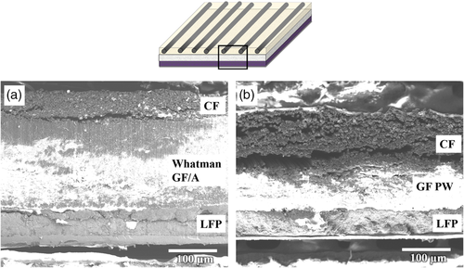
Figure 1. Cross section of the two batteries tested - note the difference in thickness of SBEs [5].
Electrochemical Performance
The battery was tested for its specific energy performance as well as its electrochemical durability. The GF PW outperformed the Whatman GF/A SBE due to its smaller thickness and thus decreased internal resistance. The published specific energy of the battery was 24 Wh/kg. The battery was found to maintain its charge over 30 discharge and charging cycles. All solid state batteries are more susceptible to temperature fluctuations than their liquid counterparts. The structural battery of this project was no different.
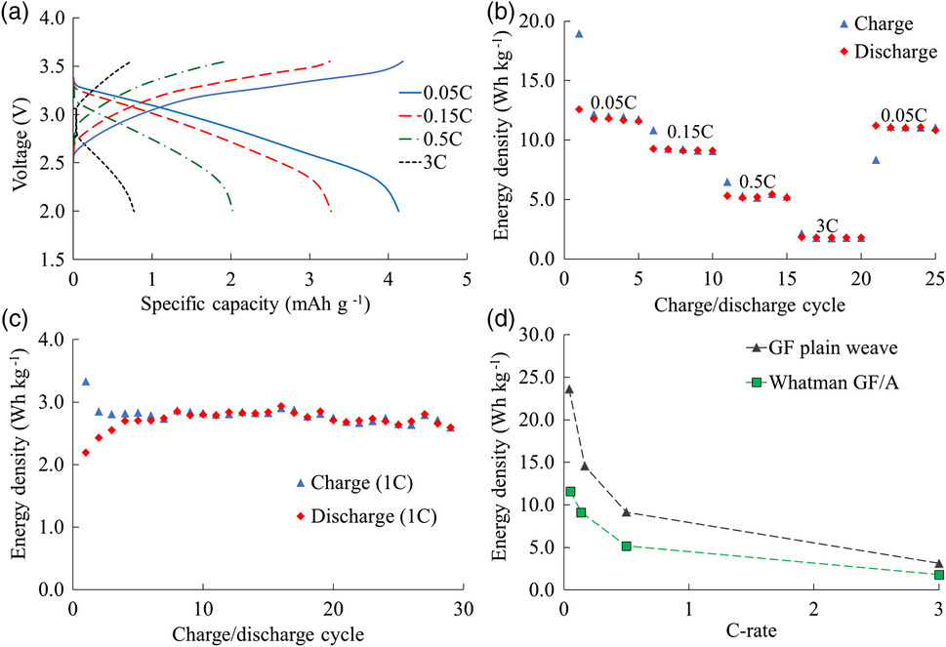
Figure 2. Electrochemical performance of the two SBE types tested [5].

Mechanical Performance
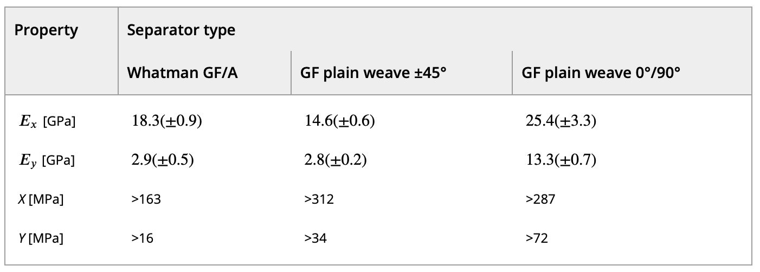
Figure 3. Mechanical performance of the two SBE types tested [5].
Directionally woven composites, such as CF, have varying mechanical properties along their different axis. The Whatman GF/A SBE is unique in that it consists of an omni directional weave. As such, the Whatman SBE performs identically in all directions. However, the Whatman SBE must be thicker than its plain weave counterpart. The GF PW outperformed the Whatman GF/A in almost all mechanical applications. The PW has multiple elastic moduli because of its directionality. The report ultimately published 25.4 GPa as the elastic modulus of the battery. Table 1 compares the elastic modulus of the battery with several common structural materials.

Material | Young's Modulus, [GPa]
7075 Aluminum | 71.7
1045 Steel | 200
IMS65 | 290
Structural Battery (GF) | 25.4
Table 1. Elastic moduli of several
common materials.

- Conclusions
SORCERER has proven the structural battery concept to be feasible. Performance is currently limited compared to existing energy storage systems and structural components. Multifunctional capability will be able to offset these shortcomings in transportation energy storage applications. Currently, the technology is limited by the development of solid state batteries in general. Continuing advancement of solid state batteries is necessary to make structural batteries more capable. Structural battery technology is still incredibly young. The applications of the technology over the years to come could revolutionize electric vehicles and aircraft alike.

- References

- https://www.eia.gov/energyexplained/use-of-energy/transportation.php
- https://www.aps.org/publications/apsnews/201208/backpage.cfm/
- https://cleantechnica.com/2020/10/10/teslas-new-structural-battery-pack-its-not-cell-to-pack-its-cell-to-body/
- https://www.sorcerer.eu/pages/about.html
- https://onlinelibrary.wiley.com/doi/10.1002/aesr.202000093

