Latest Tesla Battery Design
A Review of Present and Future Design Concepts and their Energy, Thermal, and Manufacturing Cost Benefits

Shashank Subramaniam

Candidate for Master of Engineering in Energy Systems (Class of 2022)
University of Illinois at Urbana-Champaign

Paper submitted as part of term requirement for NPRE 498 (Energy Storage Systems), Spring Semester, 2021.
Abstract:

The automotive industry is in the midst of a rapid push to electrify vehicle platforms, in order to reduce on-the-road, vehicle propulsion-related emissions. Since the start of the 21st century, Tesla has been an industry leader, with the largest offering of battery-powered electric vehicles of any automaker in the world. Tesla has made sweeping iterative changes to the design of lithium ion batteries used in its vehicles, with each design increasing the total energy capacity of each battery pack and the total driving range of the vehicle. This paper elaborates on several things, including: the climate and emissions challenges that motivate the manufacture of electric vehicles, the typical components and architecture of a lithium ion battery, present and future battery design concepts developed by Tesla, and the benefits of future Tesla battery concepts (measured in terms of extended battery capacity, better thermal management, heightened engineering reliability, and manufacturing cost reduction).

Introduction:

Clean energy is one of the world’s greatest needs of the 21st century and its production is vital to fuel the development of the global population. The global population has grown exponentially since the start of the 20th century. Current estimates, such as the one published by the University of Oxford (Figure 1a), place the world population at 7.8 billion in the year 2020, while predicting that the population will eclipse 11 billion by the year 2100. As a result, organizations such as the United States Energy Information Administration (EIA) agree that world energy demand and consumption all over the world will continually increase for the foreseeable future. U.S. EIA predictions for future energy consumption can be found Figure 1b, taken from the 2019 edition of the U.S. EIA International Energy Outlook.

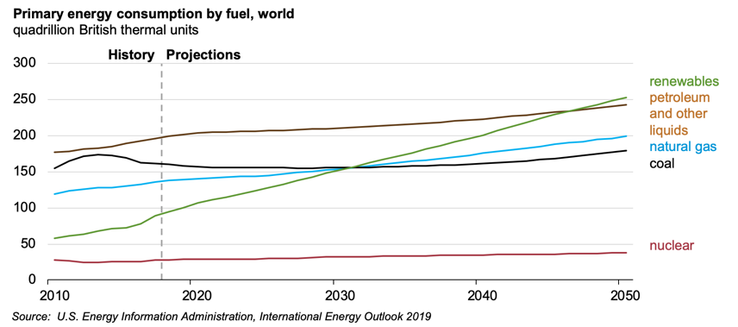
- (b)
Figure 1: Global Population and Energy Demand Trends. (a) Global population growth over time. Population is estimated to be around 7.8 billion as of 2020, and predicted to eclipse 11 billion by the year 2100.¹ (b) Historical energy consumption along with future projections which assume consistent growth in energy demand.²

The world’s energy demand ranges from heating and cooling, to transportation, to power generation. To satisfy this demand, the world has historically relied primarily on burning fossil fuels such as coal, petroleum, and more recently, natural gas, as shown in Figure 1b. Unfortunately, excessive reliance on fossil fuels has caused atmospheric levels of carbon dioxide and other greenhouse gases to reach historic high levels in the last 50 years, which has resulted in an alarming rate of increase in global average temperatures, as shown in Figure 2. As a result of rising global temperatures, the world has seen phenomena such as melting ice caps, rising sea levels, hotter summers combined with colder winters, and increasingly frequent patterns of severe weather storms such as hurricanes.³

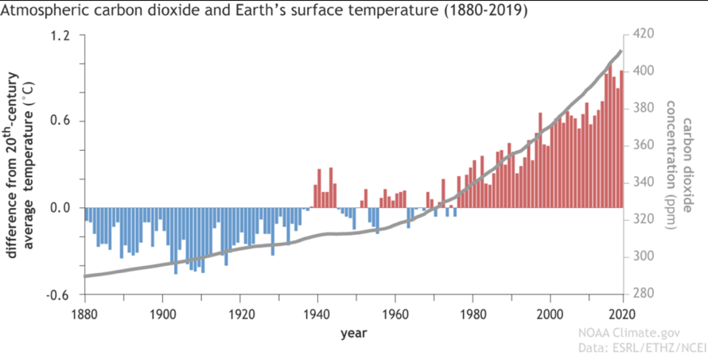

Figure 2: A National Oceanic and Atmospheric Administration plot depicting the close relationship between atmospheric CO₂ levels and elevated global average temperatures over the last 40 years.⁴

Scientists predict that climate change will reach an irreversible state if the average global temperature rises by 2ºC from its current level.⁵ This realization has prompted the international community to invested in initiatives such as the Paris Climate Accord, which aims to develop a framework for countries to one day progress towards zero-emissions status. The Paris Climate Accord lays out many avenues for countries to take to reduce emissions, ranging from displacing fossil fuels (oil, coal, and natural gas) with renewable sources of energy (solar, wind, hydroelectric, and geothermal, among others), to investing in technologies carbon capture and sequestration, to passing legislation mandating that automotive companies adhere to stricter vehicle emissions standards.

This last of the above objectives is particularly relevant to Tesla. As shown in Figure 3, the EPA published data which estimated that 29 percent of the total American greenhouse gas emissions for the year 2019 came from the transportation industry.⁶ It is important to note that this figure of 29% accounts for on-the-road, propulsion-related emissions and do not include the emissions and carbon intensity that is involved in the production process (i.e. raw material extraction and refinement, and vehicle construction). This means that automotive companies can play a huge part in reducing this figure of 29% emissions, by developing zero-carbon propulsion systems for vehicles. There are several technologies that could satisfy this need, including hydrogen fuel cells (in development by companies such as Ford Motor Company and Toyota), hybrid hydrogen gas-powered engines (currently being developed by Toyota for racecars), and batteries. While the hydrogen economy has grown at a less than ideal rate to grow in scale within the automotive industry over the last couple of decades, the lithium ion batteries have shown much promise as a portable source of energy storage, and Tesla has invested billions into industry and academic partnerships to scale up its battery manufacturing and research operations.

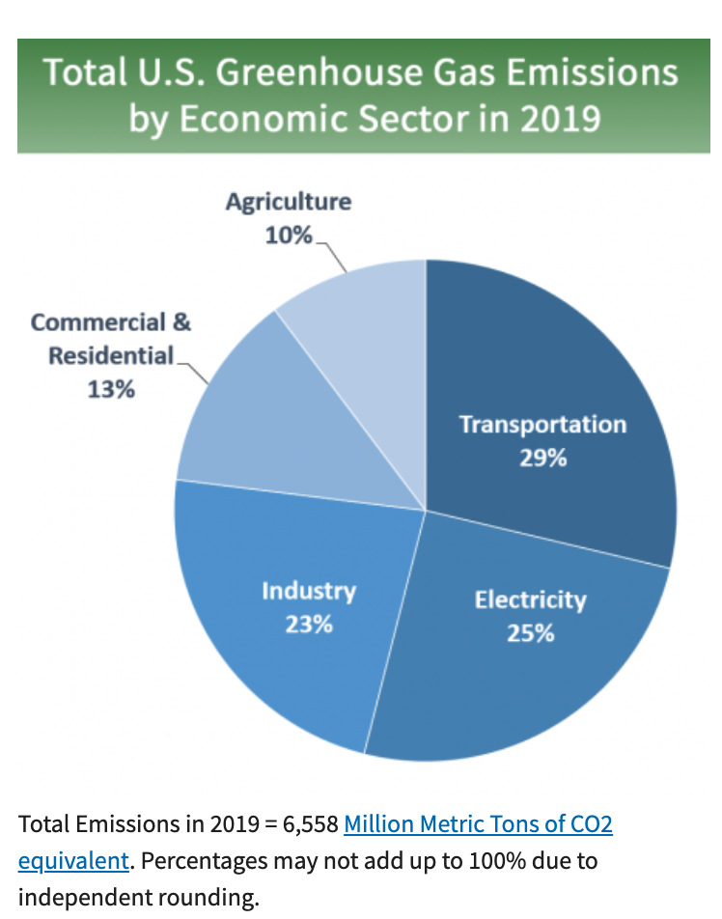

Figure 3: Data published by the Environmental Protection Agency, which shows that 29% of all U.S. greenhouse gas emissions for the year 2019 came from the transportation industry.⁶

How Batteries Work:

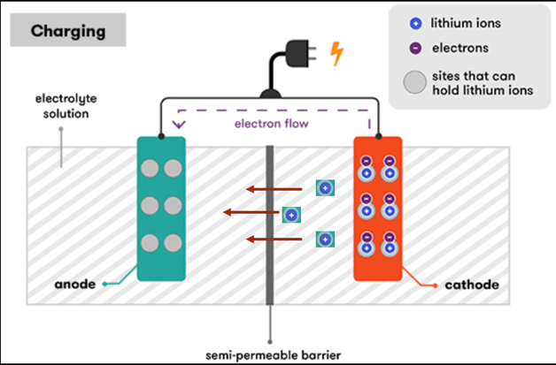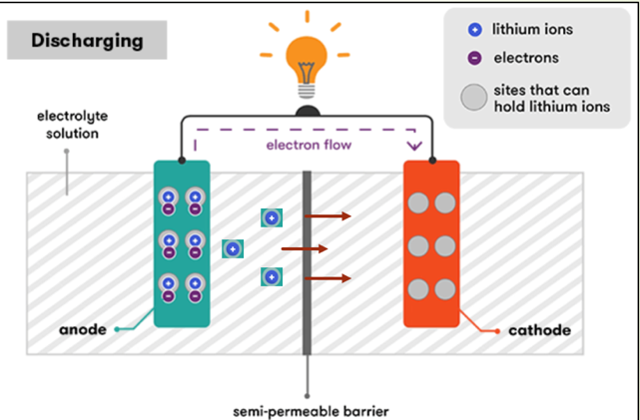
- (b)
Figure 4: Diagrams showing the electronic and ionic transport processes that occur within a battery as it: (a) charges, and (b) discharges.⁷

The primary benefit of a battery is that it is a fully-enclosed, portable means of storing electrochemical energy. The portable nature of battery technology makes it an ideal device to power a variety of portable electronics of various sizes, including phones, laptops, and automobiles. Figure 4 highlights the typical charging and discharging processes that occur within a battery. As shown in Figure 4a, as a battery is charged, lithium atoms that reside in the cathode are stripped of their electrons. The electrons are diverted via an external circuit, while the remaining positively-charged lithium ions travel upstream from cathode to anode, diffusing through an electrolyte solution (propelled by the formation of an electrochemical gradient formed by the ionic charge imbalance between cathode and anode) and across a semi-permeable layer that separates the cathode and anode. Finally, lithium ions and their loose electrons recombine and settle into the vacant space in the molecular lattice of the anode (this process is called ‘intercalation’). As shown in Figure 4b, discharging simply reverses the direction of flow by electrons and ions. The ability of a battery to store charge is influenced by the material combinations that are used to construct the electrodes. Figure 5a shows how lithium ions intercalate into the vacant lattice space of the anode and cathode. Today, high-scale commercial battery production processes utilize carbon (in the form of graphite) for the anode and one of several lithium-metal-oxide combinations (most commonly lithium cobalt oxide) for the cathode. Of the various battery chemistries that have been developed, lithium ion chemistries are preferred by Tesla for their high specific energy and energy density. Current research efforts focus on developing alternative materials that can be substituted for carbon (to increase the energy capacity of the anode) and cobalt (to reduce the overall material cost of the cathode).

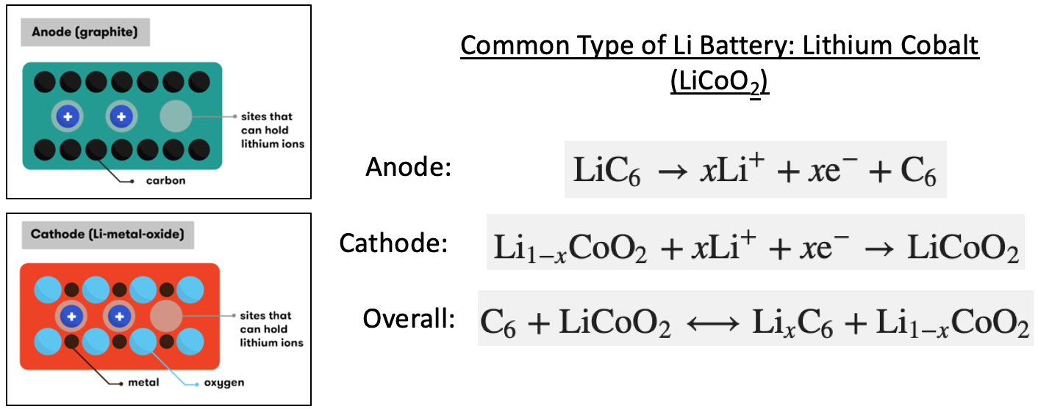
- (b)
Figure 5: (a) A visualization of battery electrodes. (b) A sample set of electrochemical half-cell reactions for a lithium cobalt oxide battery.⁷

One of the advantages of lithium ion batteries is that that can be manufactured in a variety of form factors. Additionally, batteries have an innately modular design which allows them to be packaged together in tight enclosures, vastly scaling up the overall storage capacity, as visualized in Figure 6. The battery pack in Figure 6 is an example of can be found in the base platform of an electric vehicle today.

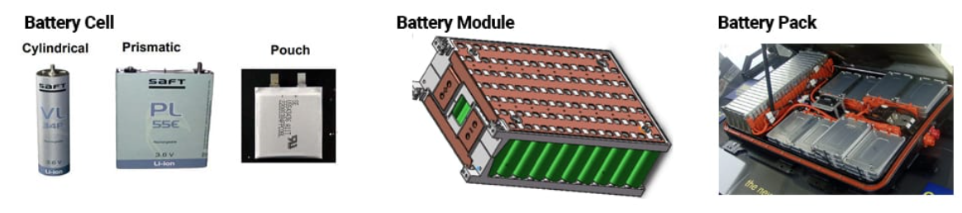

Figure 6: Examples of several common lithium ion battery form factors (cylindrical, prismatic, and pouch cells), as well as a visualization of how individual cells can be packaged into a battery module, as well as several battery modules being packaged into a battery pack.⁸

Tesla’s Battery Design

While companies such as General Motors are investigating the viability of the pouch cell form factor, Tesla has long used a cylindrical form factor, primarily manufactured in partnership with Panasonic Corporation (although, Tesla is currently in talks with several other battery manufacturers, looking to form partnerships to aggressively scale up its overall battery production). Tesla’s two most current battery cell sizes are compared in Figure 7. Of the two sizes depicted, the 18650 cell is the older, more mature design. As shown in Figure 7, the cell has a diameter of 18 millimeters and a height of 65 millimeters, while the 2170 cell (sometimes labeled as ‘21700’) has a diameter of 21 mm and a height of 70 mm. Table 1 contains data published by Panasonic, including the rated mass, volume, voltage, and charge capacity. Using these, the nominal energy capacity, energy density, and specific energy has been calculated for each cell size. Per the calculations in Table 1, the 2170 cell provides a 14.7% increase in energy density and a 15% increase in specific energy over the 18650 cell. This increase in energy capacity has been planned and rolled out over several years, in order to expand the driving range of Tesla vehicles.

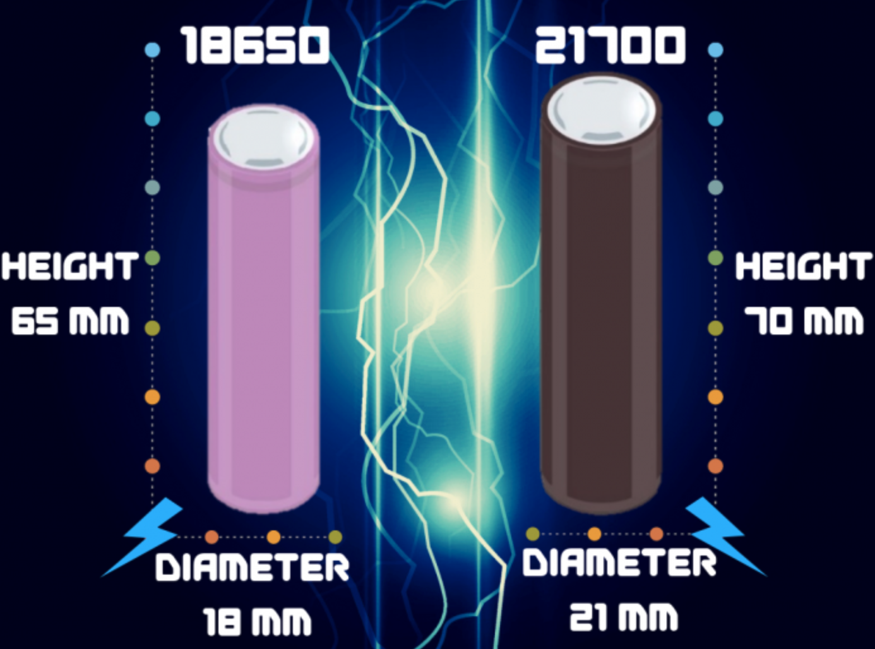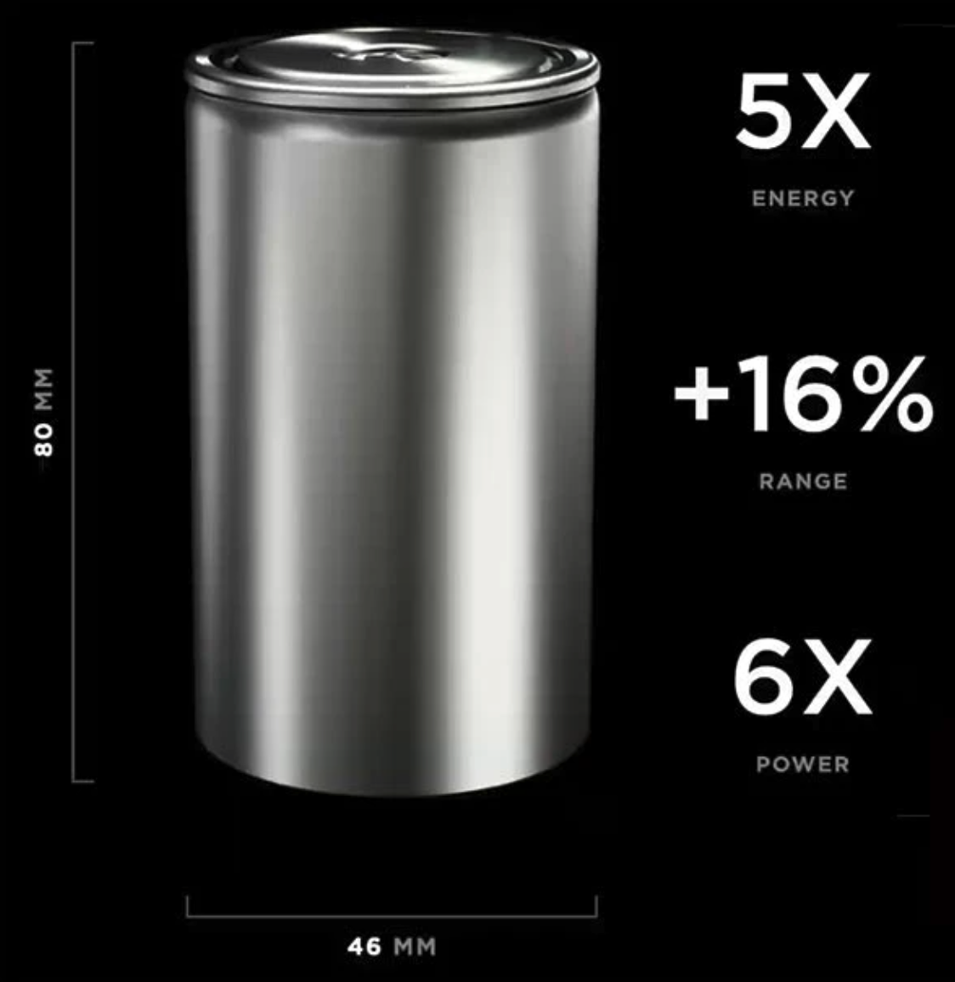
- (b)
Figure 7: A side-by-side comparison of: (a) two cylindrical battery sizes designed by Tesla and currently manufactured by Panasonic (18650 and 21700)⁹, as well as (b) a future design concept unveiled by Tesla at its 2020 ‘Battery Day’ event (4680).¹⁰

Table 1. Comparison of 18650 and 2170 cell specifications. Nominal voltage and charge capacity data are published by Panasonic.⁹
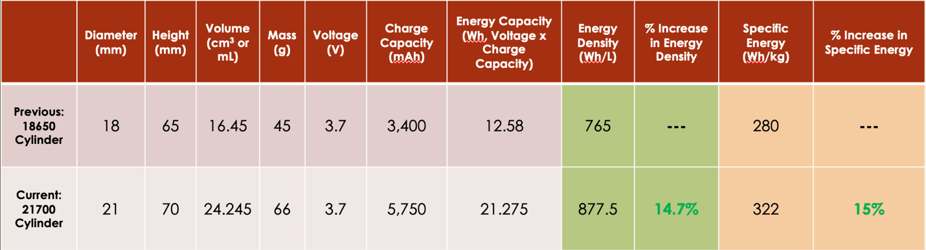
Proposed Design Changes

In September of 2020, Tesla unveiled a future battery cell design concept, a 4680 cylindrical cell, as part of its annual ‘Battery Day’ promotional event. Following the same naming convention described above, the 4680-size cells will each have a diameter of 46 millimeters and a height of 80 millimeters. Tesla advertises that each 4680-size cell will store 5 times the energy of a single 2170 cell, while increasing vehicle range by 14-16% and raising overall battery pack power by a factor of 6.¹⁰ Currently, Tesla packages exactly 4,416 of the 2170 cells into a single battery pack, and it has calculated that it can fit a total of 960 of the 4680 cells into the exact same tray space based on the volume available. This provides an advantage in that it allows for the battery packs of older vehicles to be retrofitted with 4680 cells. Table 2 compares total energy capacity calculations for a full battery pack comprised of the 2170 versus the 4680 cells. As shown in the table, a battery pack filled with 960 of the 4680 cells will provide a 13.4% increase total energy capacity than the existing battery pack filled with the 2170 cell.

Table 2. A comparison of the total estimated battery pack energy capacity for the 2170 cell versus the 4680 cell.
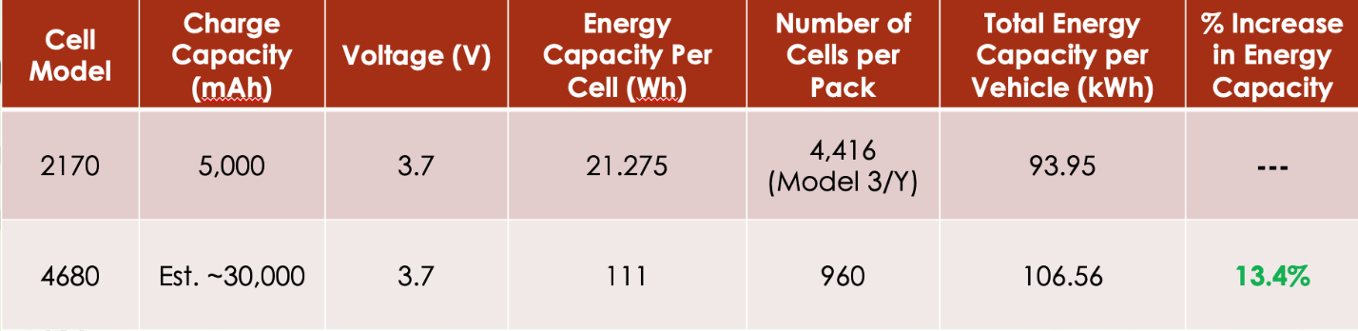

In addition to providing an increase in vehicle range, the new 4680 will provide a distinct benefit in for the form of cost reduction, due to reduced steel usage for battery cell casings. The steel casing takes the shape of a cylinder, and the surface area of a cylinder can be calculated using the formula found in Equation (1).

$Surface Area of a Cylinder=\frac{πD^{2}}{2}+πDH$ (1)

Table 3 shows the results of using Equation 1 to compare the total sheet area of steel required for a 4680 battery pack versus a 2170 battery pack. The 4680 battery will use roughly 39% less steel than the 2170 battery, which will amount to a substantial cost reduction for Tesla.

Table 3. Comparison of the total sheet area of steel required for a 2170 battery pack versus a 4680 battery pack.
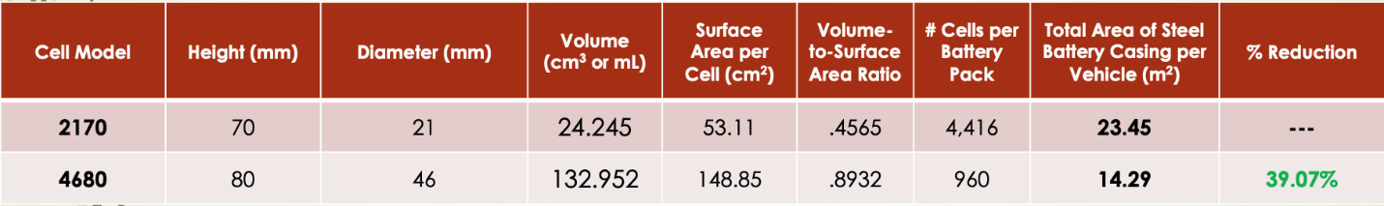

In addition to resizing its battery cells, Tesla has completely redesigned the internal structure of the 4680 cell. A typical battery has current collection tabs that make contact the anode and cathode terminals (depicted in Figure 8a), and these tabs are statistically one of the most highly likely components to fail. They are fast to corrode and can be prone to overheating. Additionally, the tabs risk getting separated and losing electrical contact over time. This is especially dangerous, since tab separation can create an entry point for air to flow into the battery. The lithium inside the battery can combust if exposed to oxygen in the air at high enough temperature, and this reaction is the cause of the Tesla battery fires that are commonly reported in media. To reduce the risk of failure associated with the battery tab, Tesla decided to do away with the tab all together, unveiling the tab-less, ‘shingle’ design shown in Figure 8b. Tesla advertises that the new tab-less 4680 cell design will allow for easier welding, better electrical contact between conductive layers, and a tighter seal preventing air entry into the battery. All of these are predicted to combine to allow for better overall thermal management of the battery.

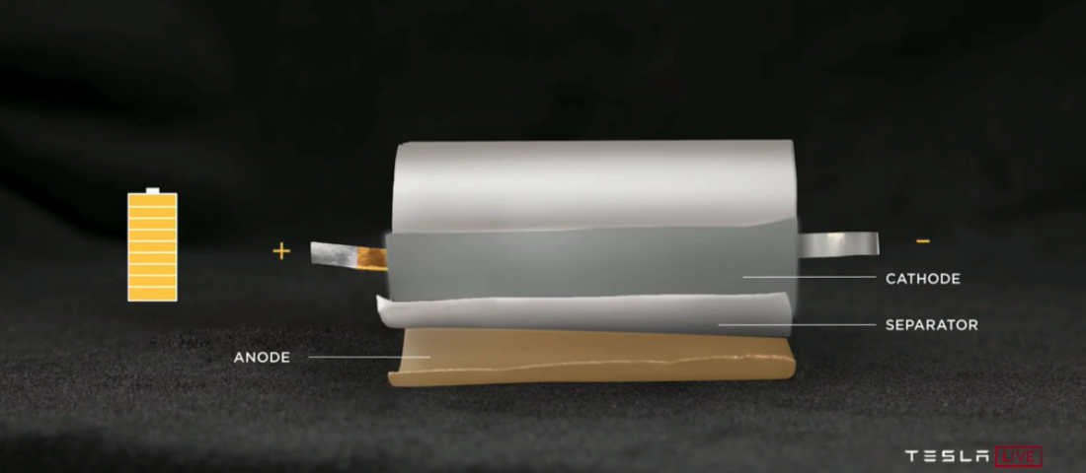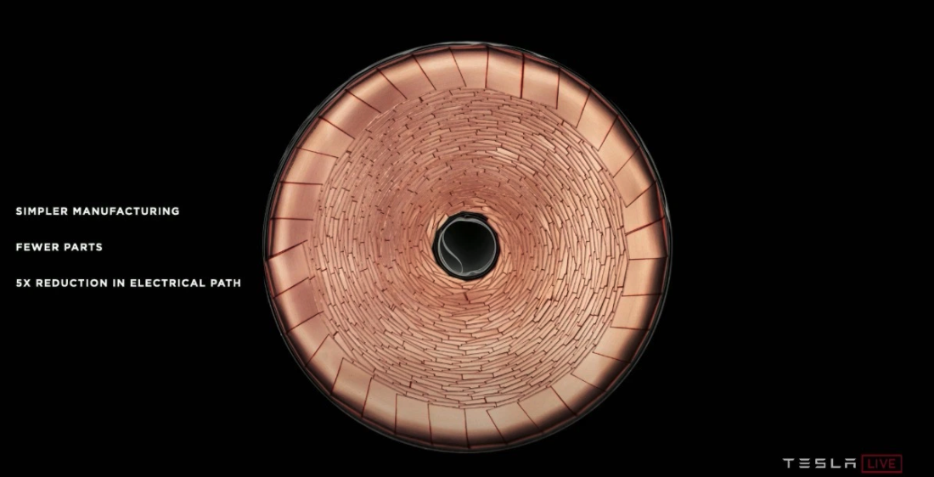
- (b)
Figure 8: A side-by-side depiction of a conventional tabbed cylindrical battery next to Tesla’s tab-less 4680 battery concept.¹¹

Tesla has also redesigned the architecture of its battery pack. Previously, it used a set up similar to the one depicted in Figure 6, with the pack being comprised of several smaller battery modules. With the 4680 battery, Tesla is planning to do away with the concept of a module all together, instead migrating toward the new battery pack design, which was presented by Tesla at its 2020 Battery Day, in Figure 9. The battery pack will consist of a single tray that is 40 cells deep and 24 cells wide (hence the estimate of 960 total cells per pack). As detailed above, the tray dimensions will not change, thus allowing new battery packs with the 4680 cell to be retrofitted into the same space required by current battery packs with the 2170 cell.

Getting rid of battery modules will save Tesla quite a lot of money on raw material costs, since the existing module casings will no longer be needed. This will further result in ample manufacturing cost savings, since it will require fewer processing steps thereby eliminating the need for several key construction equipment. Additionally, removing the module casings will allow Tesla to reduce the total number of cell-to-module and module-to-module connection points (and their ancillary wires and electrical circuit boards). This will drastically reduce the number of potential points failure points present in each battery tray, which will help to strengthen the overall engineering reliability of the battery pack. As shown in Figure 9, Tesla advertises that the new design changes will result in a 10% mass reduction of the battery pack, a 14% increase in vehicle range (which compares favorably to the increase of 13.4% calculated in Table 3), and a total of 370 fewer parts in the battery pack.
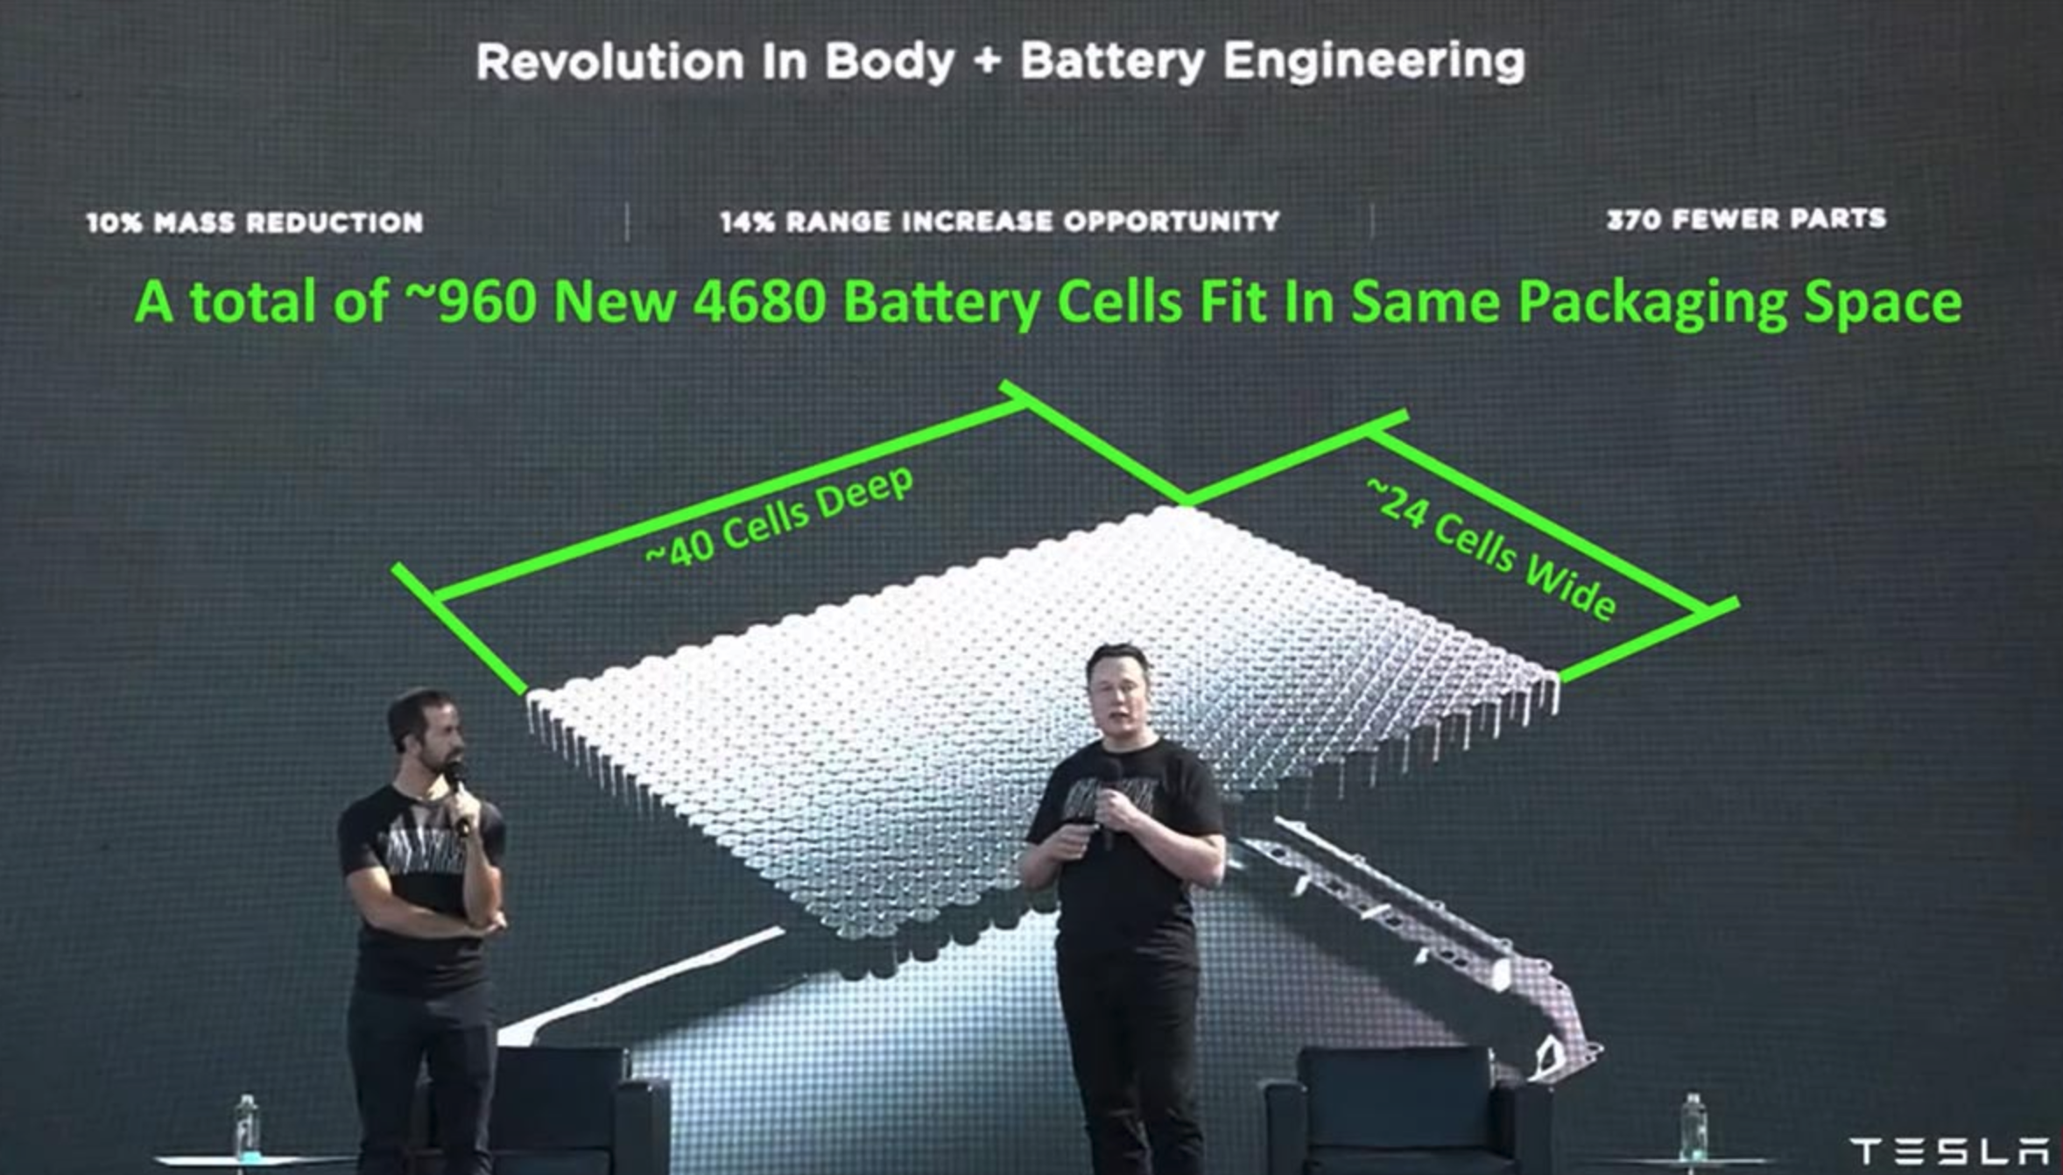

Figure 9: A schematic of Tesla’s proposed future battery pack architecture.¹²

Discussion/Conclusions

The sweeping changes that Tesla has unveiled all combine to form a huge step forward to extend vehicle range, raise battery performance, strengthen engineering reliability, and reduce manufacturing cost. These are all things that need to be continuously improved with regularity over the coming decades in order to help drive down the price point of vehicles, thereby encouraging consumer investment while aiding in vehicular emission control. Tesla also needs to continue to pour resources into researching alternative electrode chemistries. Research is being done to investigate the viability of materials such as silicon as a replacement for graphite in battery anodes, since studies have shown that lithium silicon alloys (such as Li₂₂S₅) have specific energies that can be over 10 times higher than that of lithium carbides (such as LiC₆), thus providing a huge potential for massive increase in vehicle range.¹³ However, silicon-based anodes are not currently as stable, showing faster mechanical degradation than graphite anodes. Research needs to be done to develop more stable silicon anode chemistries before they can become a reliable fixture in electric vehicles.

Additionally, Tesla is investigating the feasibility of partially substituting the cobalt found in its lithium-cobalt-oxide cathodes. Cobalt is known to exist in extremely limited reserves (only 7.1 million metric tons globally) and consequentially is very expensive to source ($45,000/metric ton). Tesla has developed a cathode chemistry that partially utilizes 75% nickel ($30,000/metric ton, 300 million metric tons global reserve) and 5% aluminum ($2,400/metric ton, 40-75 billion metric tons global reserve in the form of bauxite), thus reducing cobalt usage by 80%. While this is predicted to slightly reduce the overall performance of the cathode, it will significantly reduce the cost of raw material extraction and refinement, thereby reducing the overall manufacturing cost of each vehicle.

Advances in electrode chemistry are one of the most pressing goals to attain if Tesla is to achieve its targets of better battery performance, longer lifetime, and lower cost, thereby allowing electric vehicles to gain greater market share in the automotive industry while reducing transportation emissions and slowing the effects of climate change in the 21st century.

References:
- https://ourworldindata.org/world-population-growth-past-future
- https://www.eia.gov/outlooks/ieo/pdf/ieo2020.pdf
- https://www.climate.gov/news-features/climate-qa/if-carbon-dioxide-hits-new-high-every-year-why-isn%E2%80%99t-every-year-hotter-last
- https://climate.nasa.gov/effects/
- https://unfccc.int/process-and-meetings/the-paris-agreement/the-paris-agreement
- https://www.epa.gov/ghgemissions/sources-greenhouse-gas-emissions#:~:text=In%202019%2C%20greenhouse%20gas%20emissions,of%20U.S.%20greenhouse%20gas%20emissions
- https://www.science.org.au/curious/technology-future/lithium-ion-batteries
- https://www.sciencedirect.com/science/article/pii/S2590116819300116
- https://www.sciencedirect.com/science/article/pii/S0378775320309186
- https://www.futurecar.com/4282/A-Closer-Look-at-Teslas-New-4680-Cell-Battery-Pack#:~:text=The%204680%20batteries%20are%20expected,longer%20features%20any%20individual%20modules
- https://techcrunch.com/2020/09/22/tesla-introduces-its-tabless-battery-design-on-the-road-to-10-terawatt-hours-of-production/?guccounter=1
- https://electrek.co/2021/01/19/tesla-structural-battery-pack-first-picture/
- https://gcep.stanford.edu/research/factsheets/liionbattery_selfhealingpolymers.html

