Counter-Rotating Wind Turbines

Aanchal Gupta
Department of Aerospace Engineering
University of Illinois at Urbana-Champaign,
Urbana, Illinois 61801, USA.
aanchal5@illinois.edu

Abstract

The modern economic and environmental challenges concerning energy production leads to a demand for energy source that is cost effective and efficient. This requirement can be filled by more efficient wind turbines designs. Counter Rotating Wind Turbine (CRWT) systems extend energy extraction from the wind from a two-dimensional planar system to a three dimensional one. Their working principles and aerodynamic characteristic are considered. A discussion comparing CRWT with 2-bladed single rotor and 4-bladed single rotor is included.

Introduction

Wind energy is a clean energy sources with zero carbon emission and renewable. If fully harvested it can meet more than 200 times the annual requirement of world energy conversion.¹ A wind turbine converts the wind energy into mechanical energy by the rotation of its rotor and this mechanical energy is then converted into electrical energy using a generator. Worldwide installation of wind turbines has shown a high growth rate because power generation through a wind turbine is lower in considered as lower in cost and has higher technology maturation than that through other means of renewable energy resources.²

CRWT and Turbine Efficiency Parameters

A counter-rotating wind turbine systems (CRWT) system consists of two rotors, one rotating clockwise, the other one counter-clockwise and either a unique generator adding-up the rotation of both wind rotors, or two independent electric generators, each of them connected to a rotor.³ Figure 1 shows a counter rotating horizontal axis wind turbine system.

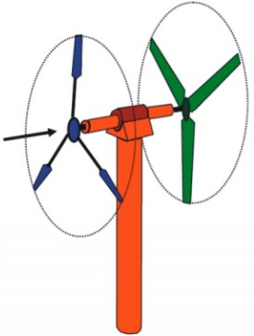

Figure 1: Horizontal axis CRWT system with two different rotor blades airfoil cross sections⁴.

The wind power extracted by a CWRT depends upon the geometry, aerodynamic parameters, and operating parameters. Hence size, shape, method of transmitting mechanical energy from the wind to an electrical generator can affect the overall efficiency of the turbine. Following are the main parameters along with its mathematical forms which affect the turbine efficiency:

  - Torque Coefficient (C_{m}) - It helps in determining the performance of a wind turbine and it is given in the equation below. Here, M [Nm] is the aerodynamic torque of the rotor, ρ is the density of air, A[m²] is the blade swept area and R[m] is the turbine rotor’s radius.

M
Cm = 0.5ρv 2AR (1)
1

  - Power Coefficient (C_{p}) - This is an important parameter which have significant effect on effi- ciency of wind turbine. Higher the value of C_{p}, better efficient wind turbine. It is expressed in equation (2). λ is the tip-speed ratio of turbine given by the ratio of linear velocity at blade’s tip,u [m/s] to wind velocity V∞. Ω stands for rotational speed[rad/sec].

λM
Cp = 0.5ρv 2AR (2)
1

u ΩR
λ = =
V∞ V∞

(3)

  - Solidity (σ) - It is dimensionless parameter on which depend the characteristics of wind tur- bine, it represented as the ratio the area of blades A_{p} and the area swept by the blades, at one spin of rotor. The rapid the turbine is (λ > 4), the lower the solidity; and therefore, the lift area of the blades is decreasing.

σ = Ap
A

(4)

The above relations give a brief understanding of the important parameters affecting the efficiency of a wind turbine. It is also crucial to understand how these parameters change with change in different aspects of a wind turbine.

Effect of design parameters on C_{p}

A study performed at Seoul National University in 2011 attempted in determining effects of design parameters on aerodynamic performance(C_{p}) of a counter-rotating wind turbine. Some of it’s results are discussed in this section. This study helped in design optimization of CRWT to yield maximum C_{p}.They used blade element momentum theory (BEMT) to quantify the relation of different design parameters such as pitch angle, rotating speed ratio and radius difference with power co-efficient.
”The blade element momentum theory (BEMT) combines the momentum theory and blade element theory for the analysis of a rotor. The momentum theory is a control volume theory based on the conservation of linear and angular momentum and the blade element theory is a theory about the forces determined solely by the lift and drag characteristics of the airfoil shape of the blade sections based on the assumption of no aerodynamic interaction between section elements.BEMT

is a reliable and effective theory for rotor design because it is based on solid physical principles and has a remarkably low computing cost.”⁵
The flow model of CRWT used in the study is shown in Figure 2. It is assumed that the rear rotor is present/operated inside the fully developed flow tube of the front rotor which means the downstream velocity is fully reduced by the front rotor before it reaches the rear rotor. And this reduced velocity act as inflow velocity for the rear rotor.

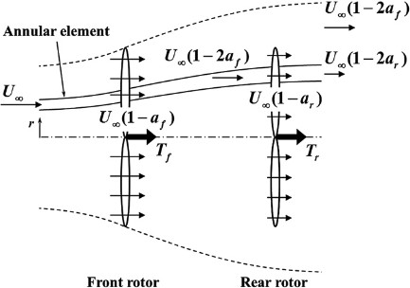

Figure 2: Flow model for CWRT used in BEMT.⁵

The numerical method using BEMT is performed for the given model. Detailed overview of equations involved in the study can be found in reference 5. Results from the study are discussed below.

  - Results
The baseline rotor utilized for the parametric study contains a generally straightforward blade geometry, which permits simple comparisons of results about concurring to the design parameters. The rotor has three rectangular blades whose the chord length is consistent with span-wise positions. The rotor robustness is 0.05 and NACA0012 airfoil is utilized for the blade. For an proficient operation of the rotor, the edges have an perfect blade twist, θ_{twist}(r) = θtip/r; where θtip is the blade pitch point. The tip speed ratio (λ) at which a maximum power coefficient is obtained is set to 8.0, which is within the range of the routine design. For this design, θtip is set to 0.3deg. Variation of C_{p} with change in different design parameters and it’s comparison with baseline rotor is listed below.

Combination of pitch angles.
To determine effect of combinations of pitch angles on performance, the baseline rotor is used for each rotor of a CRWT. Ω of each rotor is equal, which leads to λ being fixed at 8.0. The variation

of power coefficient versus pitch difference between the two rotors as a set of curves for increasing values of the front rotor pitch is shown in Figure 3.

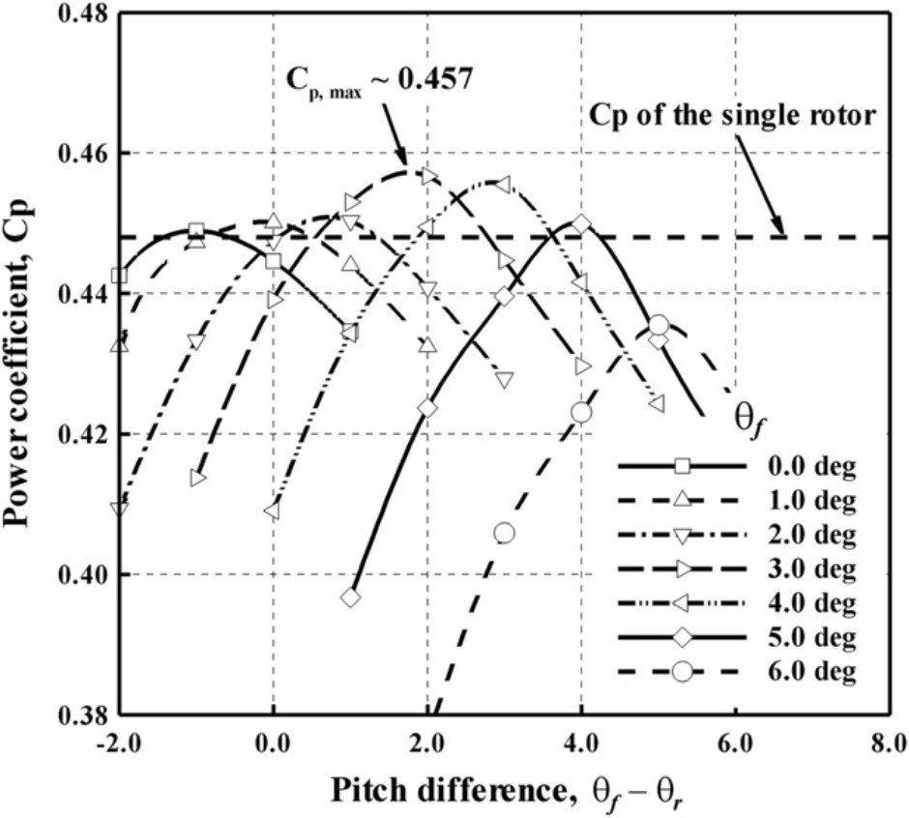

Figure 3: C_{p} v/s pitch difference between two rotors as a set of curves for increasing values of the front rotor pitch ⁵

Maximum power coefficient (C_{p,max}) for given design is achieved when the front rotor pitch is 3◦ while that of baseline rotor is at 0◦.For front rotor pitch increments, the operation condition of the front rotor moves farther from the baseline condition of the pattern rotor, and the power coefficient of the front rotor diminishes. In difference, since the obstructions of the front rotor on the rear rotor is decreased, the power coefficient of the rear rotor increments. For this reason, the maximum power coefficient is achieved when each rotor shares the entire power, not when the front rotor extricates the maximum power from the wind. In expansion, since the interference of the front rotor actuates the diminish of influx speed on the rear rotor, the pitch of the rear rotor has to be smaller than that of the front rotor for (C_{p,max}). For this study, maximum value of C_{p} was obtained when pitch angles for front rotor is 3◦ and that of rear rotor is 1◦.

Radius Difference
Figure 4 shows the change in C_{p} with radius difference between the two rotors for different pitch combinations.R_{ref} is the reference radius, which is the bigger radius of the two radii of two rotors. So when a ratio of radius difference and R_{ref} is taken, it become non-dimensional. The negative value of this quantity means that the radius of the front rotor is smaller than that of the rear rotor, and zero means that the two radii are equal. In this study, they assumed that even if the rotor radius is changed, the λ and σ are fixed to 8.0 and 0.05.
From figure 4, we observe that power coefficient decreases when non-dimensional quantity goes away from zero except after -0.2. Main reason for this is the power from the wind is corresponding to the zone cleared or area swept by the rotor, C_{p} reduces when one of the rotor radii decreases. Interestingly, power coefficient increases when non-dimensional radii difference goes below -0.2, regardless of a decrease in front rotor radius.This explains that the outer parts of the rear rotor blades recover the wind velocity as the radial expansion radius of the fully developed stream tube of the front rotor becomes smaller than the radius of the rear rotor.⁵

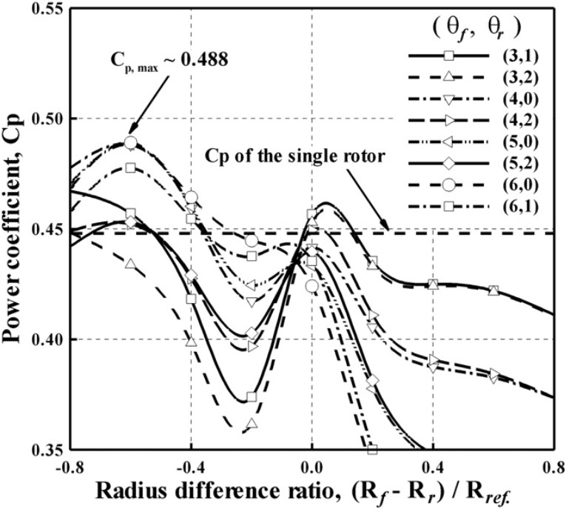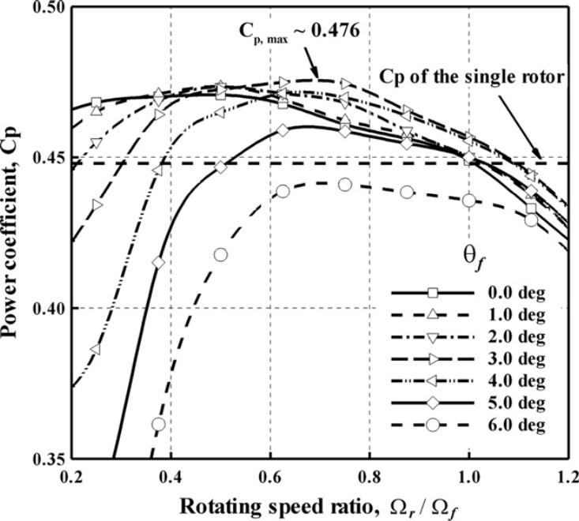

Figure 4: C_{p} v/s radius difference between two rotors for various pitch combinations ⁵
Figure 5: C_{p} v/s rotating speed ratio of the two rotors as a set of curves for increasing values of the front rotor pitch ⁵

Rotating speed ratio
The variation of power coefficient with rotating speed ratio of the two rotors for increasing front rotor pitch angles, is shown in Figure 5. To evaluate the dependence of performance (C_{p}) on rotating speed ratio only, we assume that radius of both rotors is equal, the pitch angle of rear rotor and tip-speed ratio(λ) are fixed at 0◦ and 8.0 respectively.
From figure, the maximum power coefficients for all the pitch angles is obtained at rotating speed ratio less than one (meaning both have same rotating speed).At the same rotating speed, due to decrease of the inflow velocity on the rear rotor, the angle of the relative wind on the rear rotor becomes smaller than that on the baseline rotor having maximum performance, so the power coefficient of the rear rotor decreases.⁵ Hence, the C_{p,max} is achieved when Ω_{r} is reduced to recover angle of the relative wind for maximum output of rear rotor.

Comparison with Single Rotor Wind-turbines

A study was performed at Seoul National University, which compared aerodynamic characteris- tics of a CRWT with that of single rotor having equal solidity(σ) as well as single rotor having half solidity.Hence, three kinds of rotor configurations were used which are shown in figure 6. Rotor 2S have solidity 0.061, 4S has solidity 0.122(twice of 2S) ans 2x2C have same solidity as 4S.For this study, all the rotor have equal rotating speed, pitch angle, swept angle and blade geometry.
The numerical methods used in this study was free vortex lattice method. To evaluate flow field induced due to each wind turbine, two induction factors are considered.First is wake axial inductiona_{wake} that is defined in equation 5, here V_{wake} is wind direction component of induced ve- locity. Second is wake angular induction factor(a^{t}wake) which is the ratio of wake swirl velocity(ω_{wake}) and angular velocity of rotor.

awake at
= 1 Vwake V∞
= ωwake
−

(5)

(6)

wake Ω

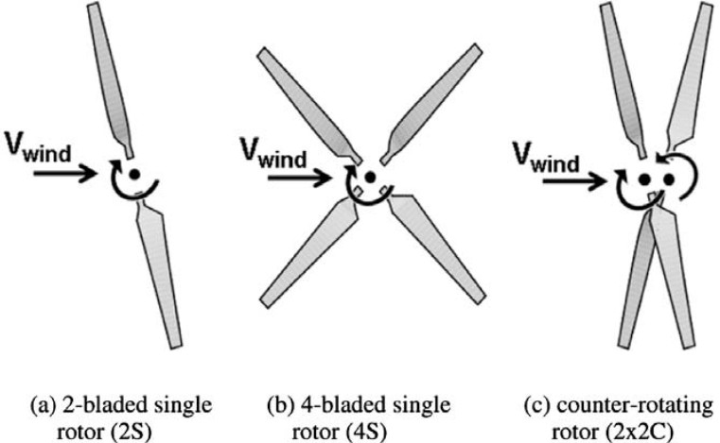

Figure 6: Three kinds of rotor configuration used in the study. ⁶

Figure 7, shows the radial variation of a_{wake} for all three configuration and the trend for each of them is similar.Tip speed ratio remain constant during this calculation. The change in the magnitude of a_{wake} for each configuration comes due to difference in solidity. 4S and 2x2C have same solidity thus have 1.7 times larger a_{wake} then 2S. This is beneficial, larger the a_{wake} higher is aerodynamic performance. Comparing 4S and 2x2C, they have same solidity but small difference in a_{wake}, the main reason for this is the interaction of front and rear rotor.
Radial distribution of a^{t}wake, is shown in Figure 8. Larger σ gives larger value of a^{t}wake, except for the case of 2x2C.”The reason a^{t}wake of 2x2C is nearly zero is that the swirl velocity induced by the front rotor is offset by the rear rotor rotating opposite direction. This phenomenon is the
swirl recovery. Because swirl velocity of a wind turbine gives a disadvantage to performance, swirl recovery of a CRWT could be of help to the performance of wind turbine.”⁶

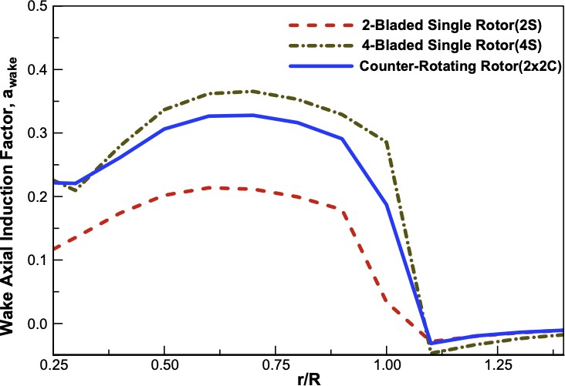
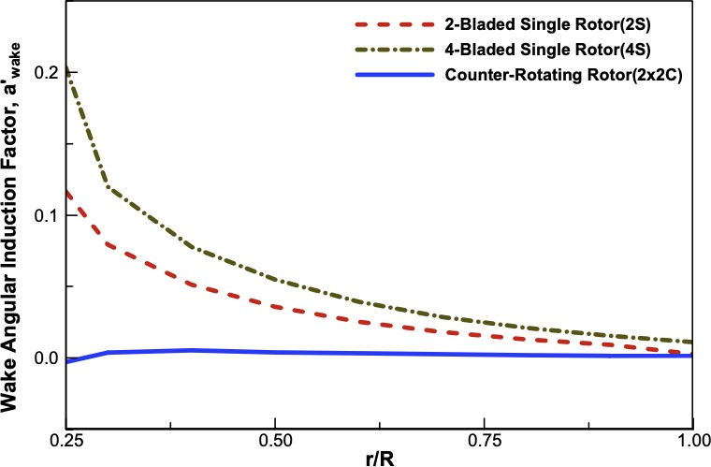

Figure 7: Radial distributions of wake axial in- duction factors at λ = 5.42.⁶
Figure 8: Radial distributions of wake angular induction factors at λ = 5.42.⁶

Figure 9 shows variation of power coefficient(C_{p}) with change in tip-speed ratio(λ).The C_{p,max} of 2S, 4S and 2x2C are about 0.36, 0.50 and 0.48, respectively. As solidity increases, C_{p,max} increases, and the λ corresponding to maximum power coefficient decreases, while C_{p} curve become more steep. The reason of tip speed ratio decrease is due to a_{wake} increase,which means that an effective angle of attack of rotor blades decreases and then larger wind speed is needed for the same rotating speed. Next, the reason of a steep C_{p} curve for higher solidity is that positive torque component

induced by lift increases as the number of blades increases, but negative torque component induced by profile drag also increases.⁶
For rotor having same solidity i.e. 4S and 2x2C the C_{p,max} of 2x2C is approximately 5% lower than for 4S. This is mainly due to interaction of front rotor with the rear rotor.”Though the 2x2C has an aerodynamic advantage of the swirl recovery, the adverse effect induced by the interaction is dominant, and the aerodynamic advantage occurred by swirl recovery is considered to hardly affect the performance of a wind turbine”.⁶

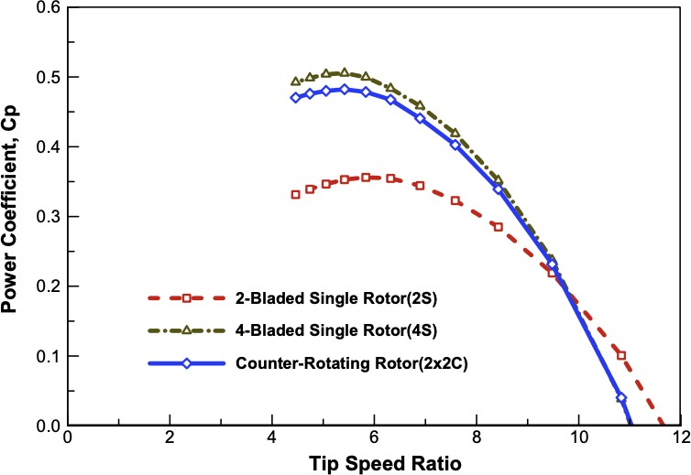

Figure 9: C_{p} v/s λ for each rotor configuration. ⁶

Conclusion

A review of working of counter rotating wind turbine systems are described. Important efficiency parameters are discussed, and their dependence on different wind and design parameters are shown. Results from a study in reference 5 are discussed which include variation of power coefficients with pitch angle, non-dimensional radius difference ratio and rotating speed ratios. Then a study mentioned in reference 6 is discussed, which gives insight on the efficiency parameter and aerodynamic characteristics Comparison for a 2-bladed single rotor, 4-bladed single rotor and 2-bladed counter rotating wind turbine systems.

References
- Jongh JA, Raghavan K, van Hulle FJL, “Power for the world - A common concept, study,” ECN-Ce95e037. ECN; 1996.
- World wind energy report 2009. WWEA (World Wind Energy Association); 2010.
- Oprina G., Chihaia R.A., E-leathey L.A.,Nicholaie ., Babutanu C.A., and Voina A.,”A review on counter-rotating wind turbines development”, Journal Of Sustainable Energy VOL. 7, NO. 3,
SEPTEMBER, 2016
- Chantharasenawong, C., Suwantragul, B., Ruangwiset, A., “Axial Momentum Theory for Tur- bines with Co-axial Counter Rotating Rotors,” Commemorative International Conference of the Occasion of the 4th Cycle Anniversary of KMUTT Sustainable Development to Save the Earth: Technologies and Strategies Vision 2050: (SDSE2008) 11- 13 December 2008, Bangkok, Thailand.
- Lee, Seungmin Kim, Hogeon Son, Eunkuk Lee, Soogab, 2012. “Effects of design parameters on aerodynamic performance of a counter-rotating wind turbine,” Renewable Energy, Elsevier, vol. 42(C), pages 140-144.
- Seungmin Lee, Hogeon Kim, Eunkuk Son, Soogab Lee, “Effects of design parameters on aero- dynamic performance of a counter-rotating wind turbine,” Renewable Energy, Volume 42, 2012, Pages 140-144, ISSN 0960-1481, https://doi.org/10.1016/j.renene.2011.08.046

